Concept of sensing using instrumentation and measurement

Course outcome: Demonstrate the ability to design, build and test sensing and measurement instrumentation circuits using resistors, capacitors, op-amps and sensors, as needed.

Learning objectives for the course
- Explain the concept of measuring a data source as a proxy for a sensing goal;
- Employ the voltage divider concept to measure sensor outputs;
- Design low-, high- and band pass filters to condition input voltages;
- Use operational amplifiers filter and amplify voltages;
- Employ computational tools to transform data
- Use Analog Discovery tools to analyze circuit performance
- Integrate knowledge to design, build and test a sensing & measuring instrument

Course Summary

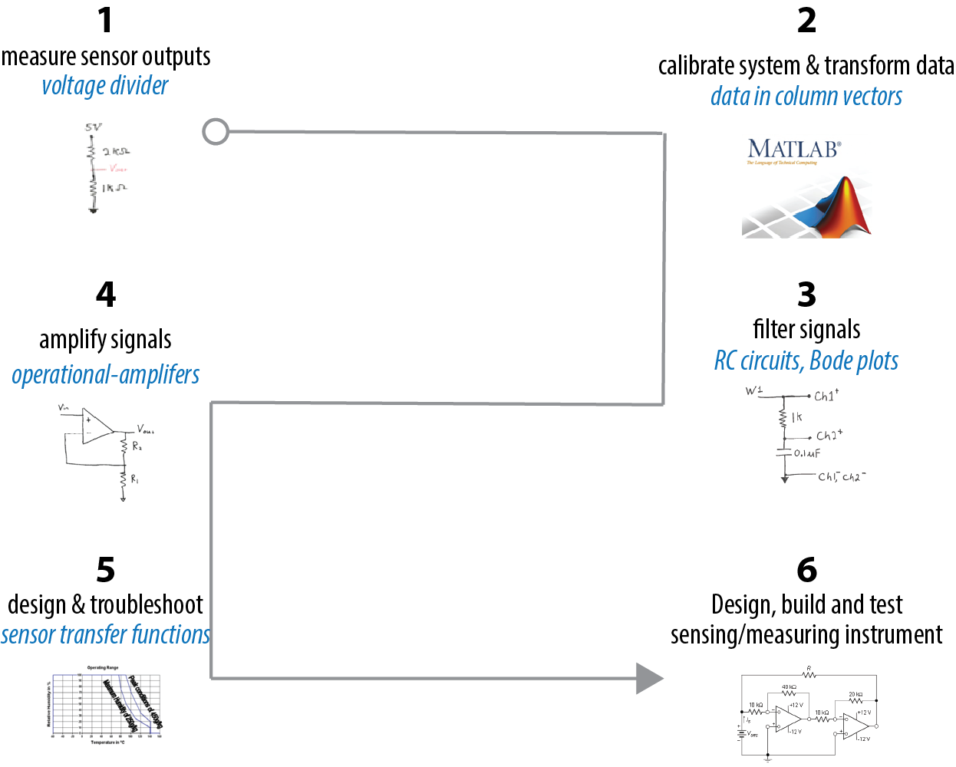

Measuring, sensing, instrumentation: the big idea
Oftentimes we desire to sense something but cannot do it directly. A way to achieve the sensing goal is to measure a proxy with instrumentation and then use math to transform the data.

For example, let’s say you wanted to sense the beating of your heart in beats per minute.

What would you do to sense your heartbeat?

Your pulse is a proxy for your heartbeat; Each pulse is produced by a single heartbeat. We’ll treat it as our measurement data source.
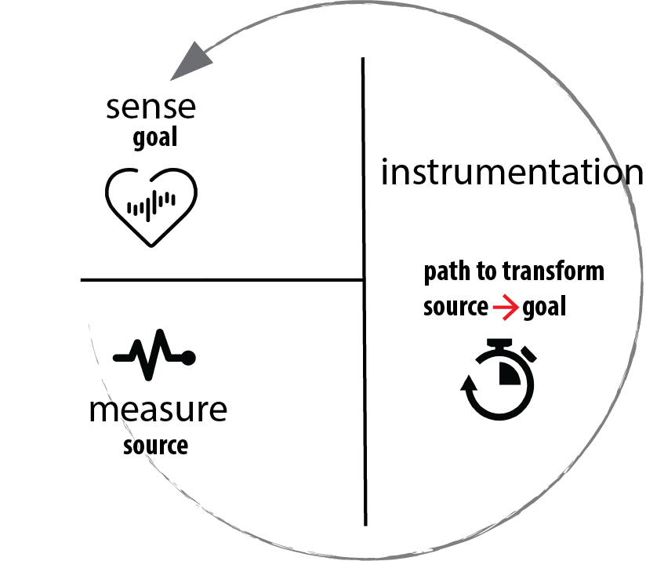
If you had an instrument to time your pulse, you could transform your measured pulse ➝ heartrate

Source transformation Goal

$\frac{\#pulses}{60 seconds}×\frac{60 seconds}{1 minutes}×\frac{1 heartbeat}{1 pulse}=\frac{\#heartbeats}{minute}$

Conversion factor = 1

Notice that conversion factors come from mathematical relationships (i.e., equations):

$60 seconds=1 minute$, or $\frac{60 seconds}{1 minute}=1$

When we use conversion factors or substitute values from an equation, we are simply transforming the original data from one dimension to another.

In ISIM in general, we will measure the source data using the instrumentation. We’ll then use math to transform the data to get the sensing goal.
Transforming measured data ➝ desired sensory data is similar to transforming °F to °C.

To get from the °F-dimension to the °C-dimension, we need to know how °F is related to °C.

In general, how do we determine the mathematical relationship when the source of measurement has a different dimension than the sensory goal? [One Answer*]
*Answer: Through experimentally measuring known quantities. This is called “calibration.” Another way is to use a relationship that has already been determined experimentally be someone else, as in the case of temperature conversation. A third method, is of course, to “google it.”
*You could experimentally determine how the two values are connected. This is known as “calibration.” Another way is to use a relationship that has already been determined experimentally by someone else, as in the case of temperature conversion. A third method, of course is to “Google it.”

