Lab 1: Simple pendulum
Goal: Measure the change in pendulum angle with time, θ v. t, using a potentiometer as a position sensor.
Learning objectives
- Memorize the relationship between V, I and R;
- Explain the mathematical relationship between Volts (V), Amps (A) and Ohms (Ω);
- Summarize how a potentiometer works;
- Recognize instrumentation as transducer(s)+ circuit;
- Use the instrumentation (Analog Devices) and sensor to measure change in angle
- Construct a calibration curve

Visual Summary
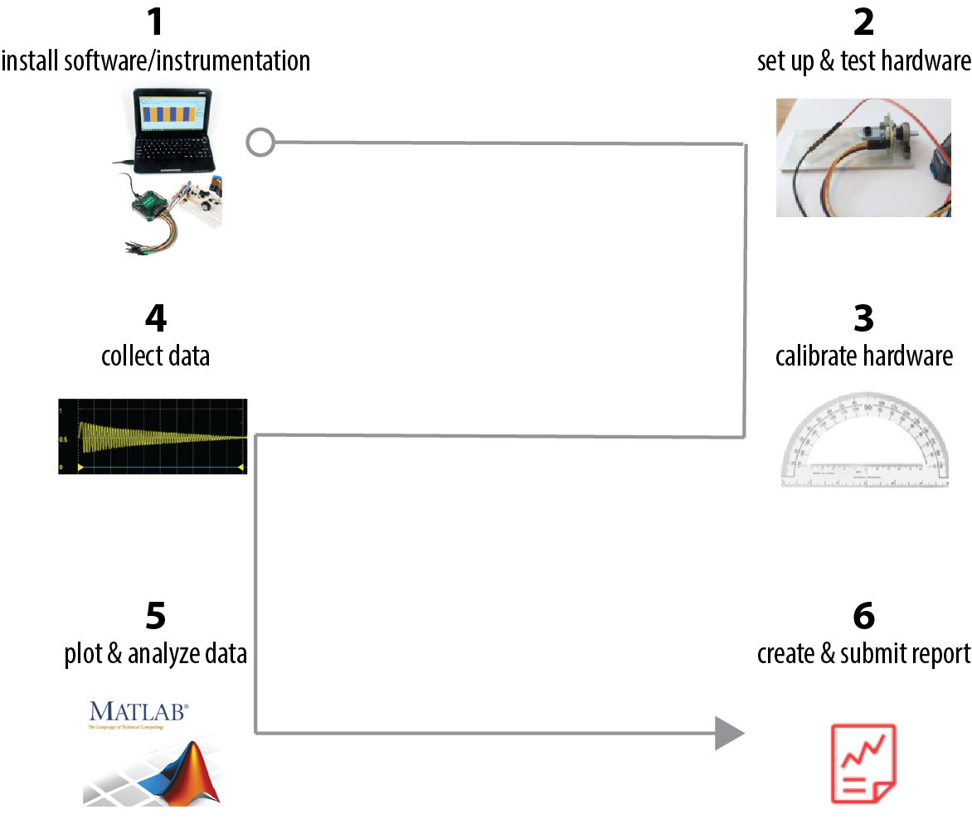

Some preliminaries: What is voltage?
What is Voltage, V?
You can think of voltage, or really, the difference in voltage, ΔV, as a measure of a difference in the number of charged particles (i.e., electrons). In the presence of ΔV, the electrons “feel” a force to flow; in fact, ΔV is alternatively called the electromotive force (EMF).

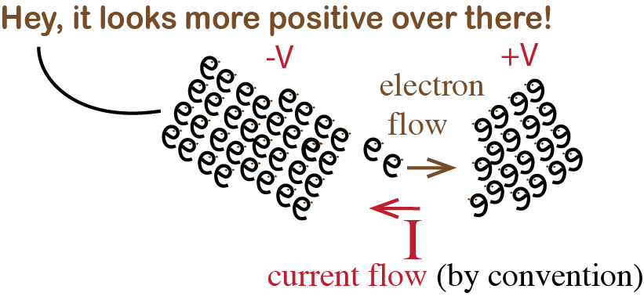
The flow of (positive) charge is called current, I, measured in Amps*.
The resistance to the flow of charge is called Resistance, R, measured in Ohms.

*The amp is named after Andre Ampere. 1 Amp is equivalent to the flow of 6.242 x 10¹⁸ electrons/second.

Voltage, Current and Resistance are mathematically related
A fairly reliable relationship for current flowing between two points is called Ohm’s Law, which tells us the change in voltage from one point to another (ΔV) equals the current (I) times the resistance between those points:

ΔV
I
R
$ΔV=I×R$ using System International (SI) units: 1 Volt = 1 Amp Ohm
$1 V=1A ∙1Ω$

Create an equation for V, I or R by covering up the value you want in this triangle

- Install software/instrumentation
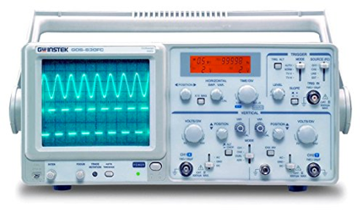
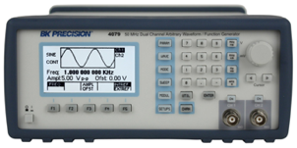
+
Digital multimeter
Analog Discovery
Oscilloscope
Function generator
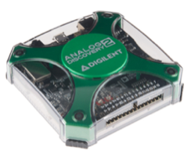
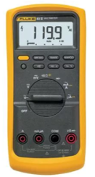
=
+
+
more

(not to scale)

The Analog Discovery (AD) device we are using this semester has the functionality of several electronic devices (seen above). It is controlled by software.
Download and install the WaveForms software.
Once you have installed the software, plug your Analog Discovery hardware into your computer’s USB port and the hardware should now be recognized.
You may need to wait a few moments and possibly reboot your computer. Open the waveforms software and your device should show up automatically.
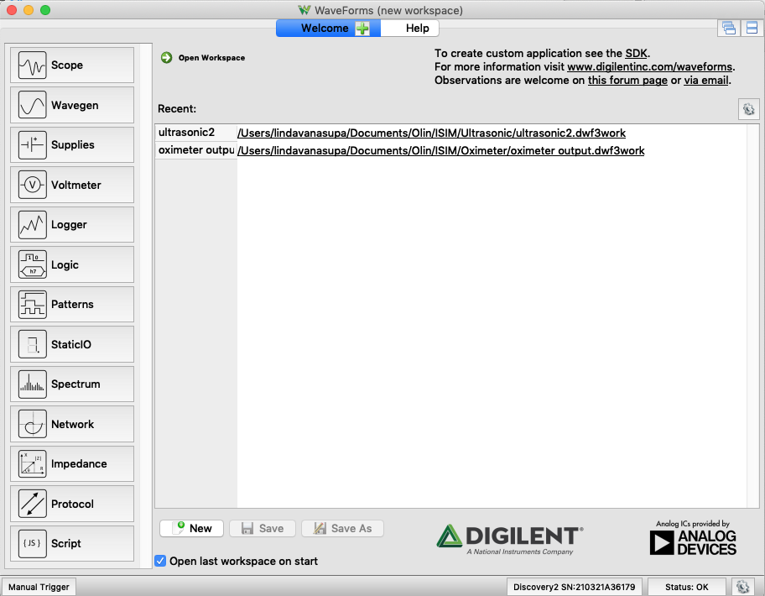
The different functions of the Analog Discovery are shown on this left-hand column.

Today, we will mostly use Scope and Wavegen.

Click on 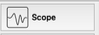 (Scope)

Click ►Run
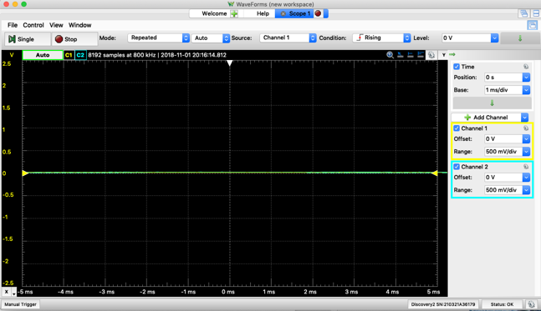
Your screen is likely to look like this (O Volts on Channels 1 and 2), since there are no inputs.

- Set up and test hardware
How does it work? A sensor, or equivalently, transducer, converts one physical quantity to another.
Today, we will couple the pendulum to a rotatable shaft of a potentiometer. The shaft is coupled to a wiper which divides the total resistance, R_{1 to 3}, of the potentiometer. When the pendulum angle 𝜃 changes, $R_{1 to 2}$ i.e., the resistance between lugs 1 and 2, changes.
shaft

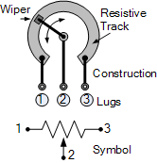

Schematic: https://www.electronics-tutorials.ws/resistor/potentiometer.html

1

2

3

We will create the circuit below. (Below is a circuit diagram, if you haven’t seen one before check out the Wikipedia page. Can you identify where the battery is? The resistor?)
1

2

3

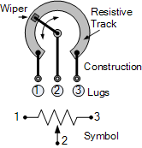

+1 V
-
0 V (ground)
R₁₋ ₃ = 10,000 Ω
V_{out}

V_{pin3} = ?

Circle the circuit element that is functioning as a sensor in the circuit diagram.
This sensor will act like two resistors in series:
$R_{total}=R_{1 to 3}= R_{1 to 2}+ R_{2 to 3}=10 kΩ$,
so that when we apply +1V at lug 1, this voltage will “drop” from lug 1 to lug 3. (Lugs are also sometimes called “pins”).
For V_{pin1}=+1V, and that wiper blade is at the middle point of the resistive track, what do you expect as a reading for

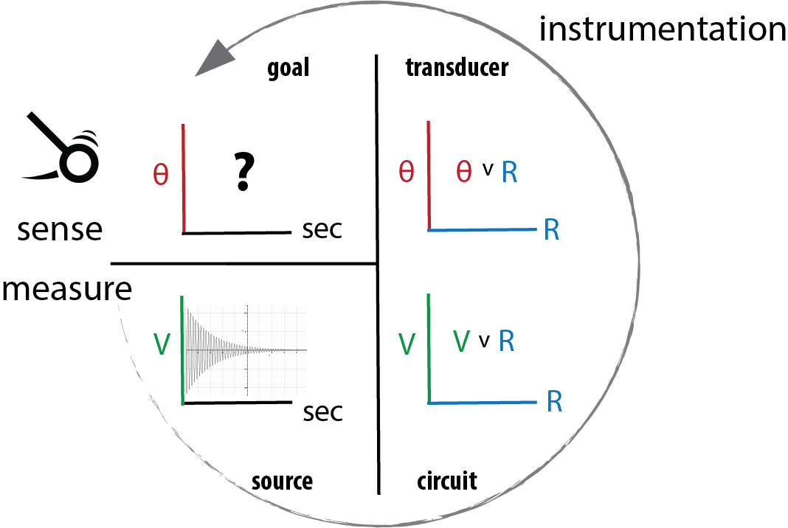
We are going to insert our sensor into a circuit so that:
V_{out} changes with $R_{1 to 2}$., which changes with 𝛳.
As shown at the right, for the swinging pendulum, we could measure ΔV v. time.
Using the circuit, if we know how ΔV is related to $R_{1 to 2},$ and how $R_{1 to 2}$ is related 𝜃, we could then convert each measured data point,
(V, t) → (V, R) → (𝜃, R) → (𝜃, t)
Notice we are just transforming from one domain (V, t) to another (𝜃, t).
But wait…there is a shortcut!
We could create a new graph, V vs. 𝛳, by measuring V for a range of fixed 𝛳 values.
If we measure V(t) and developed an equation for V(𝛳), how could we then get 𝛳(t)?

Set up the hardware to measure V v. θ
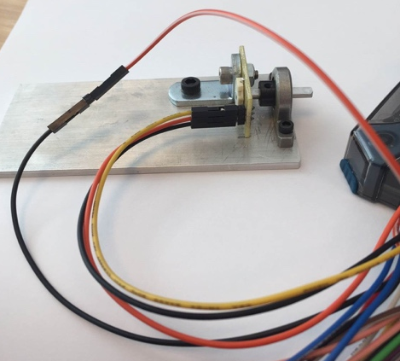
Attach the pendulum to the 𝜃-dependent resistor

1

2

3

Get one of the metal plates with the bearing and potentiometer attached, a clamp and the “pendulum.” Fix the plate to your table edge.

There are three header pins sticking out from the side of the small yellow circuit board. Each pin is soldered to the terminal lugs of the potentiometer.

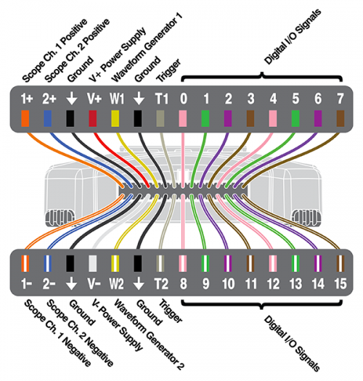
Connect the Analog Discovery (AD)

You will commonly use the two analog input channels (Scope Channel (Ch.) 1 & 2) to measure voltages – these are labeled as 1± and 2±.

This notation means that Channel 1 will measure the voltage difference between the Ch1+ and Ch1-.

The AD has several, Ground (black) connections.

Connect the (AD) Ch1- to AD Ground (you will need a connector).
Use Waveform Generator 1 to input 1V =+V_{in} (Lug 1 or pin 1 or point 1)
Use Channel 1+ to measure +V_{out} at pin 2
Connect another AD Ground to pin 3

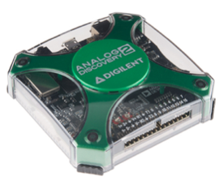
+V_{out}

+V_{in}
-
0 V (ground)

Set up the Analog Discovery (AD)

Select 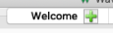.

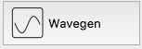
Select
Wavegen will generate a voltage wave in the shape that you specify.
For our case, we want W1 to be a constant +1 Volt relative to Ground.
Set: Type: --DC (Direct Current) & Offset: 1 V (offset 1 V above 0V).
►Run.
+1V
0V
0V

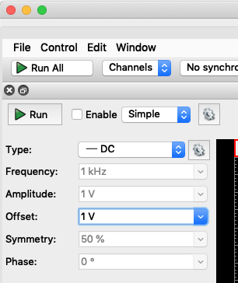

0V
0V

V_{out}
Return to the Scope:
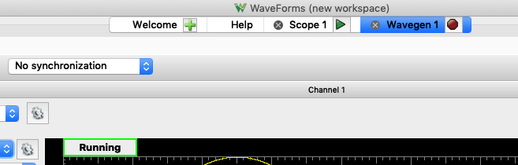

On the welcome tab you are going to now open the “Scope”. “Scope” is short for oscilloscope, which is an instrument that allows us to measure voltage as a function of time. Click the ►Run button at the top left.
Test the apparatus to ensure all is ready
While watching the Scope screen, move the axle of the device around by hand. If everything is working, you should see the voltage change as you adjust the angle. The voltage should vary between 0 and 1 volts.
On the right of the Scope screen, turn off channel 2.
You will need to adjust the x and y axis settings in Scope. Time Base: 200 ms/div and the Channel 1 range to be 1 volt per division. We will explain how to adjust the settings and read the scope display in class.
Once you think everything is working, attach the pendulum to the output shaft. Before doing so, rotate the shaft so the flat shaft edge is facing up and then gently press the pendulum onto the shaft by hand.
Set MODE: Screen
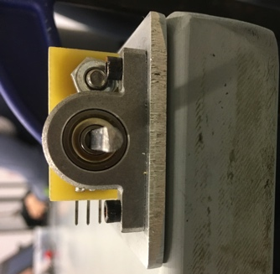
Use a bar clamp to hold the metal plate to your desk with the pendulum free to swing over the edge.

As a trial run, raise the angle and release the pendulum - you should see a signal which is proportional to the angle of the pendulum and over time should look like a damped sine wave.
Note: You may need to adjust the time scale on the Scope to see the pendulum come to rest.

- Create a calibration curve
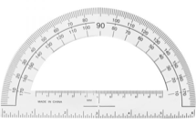
Calibrate your set up by collecting a series of Voltage values at known pendulum θ values.
Note: Calibration will be sensitive to the initial angle of the shaft when you press on the pendulum – thus you will want to conduct all your experiments and record your data with the same physical setup.
You can collect these values by using the following steps:

1. Click on View>Measurements

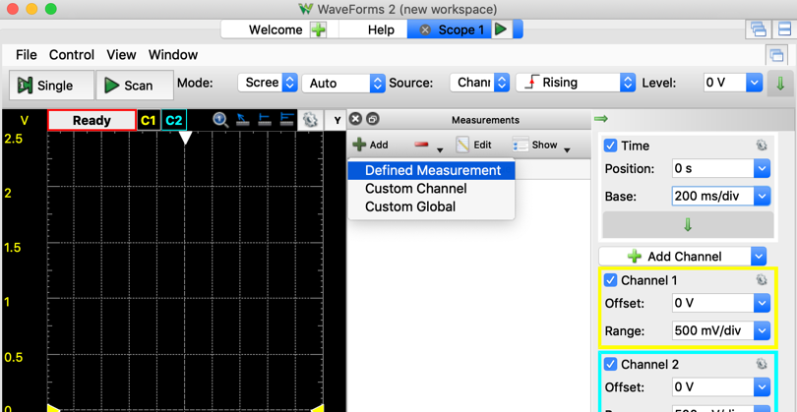

2. Add a Defined measurement

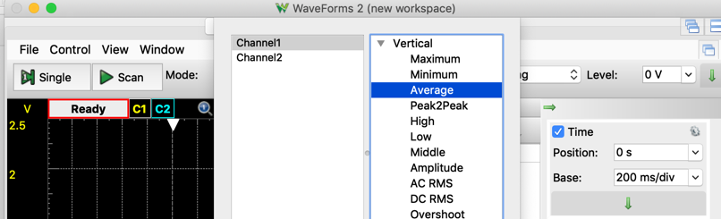
3. Channel 1, Vertical>Average.

(Optional: What should the average be? If you move the pendulum back and forth, does it read the same average voltage when it is vertical? This is a test if the pendulum is snug.)

- Generate a calibration curve
Take one of the protractors.
Change the angle of the pendulum by hand and hold it stationary at a known angle.
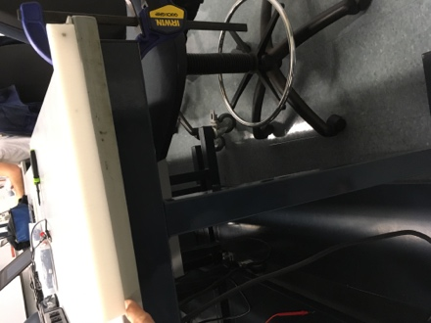
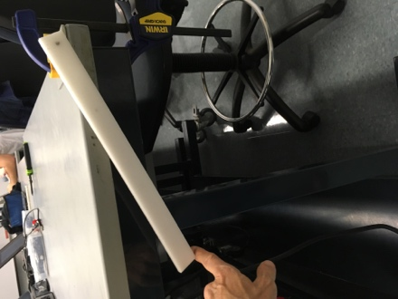
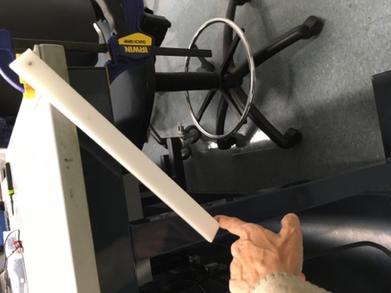
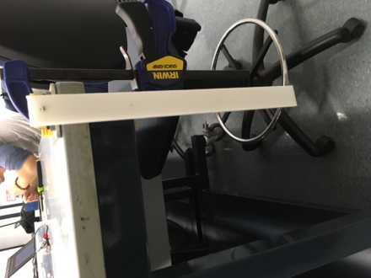

Record the voltage, Ch1 Average, versus θ.
Take enough V(θ) for $θ=±80°$ to produce an equation for V(θ), roughly every 20°. (If you can’t collect the full range due the table + clamp situation, that’s okay). Let’s define 0° as straight up and down. (You may collect more calibration data.)
This step of calibration is an important concept – we will usually need some way to connect the voltage that we measure to something physical (θ, in this case).
Make a rough plot of 3 or 4 points, including θ=0° as a data point. How is V mathematically related to θ? (linearly?, exponentially?.logarithmically?..)
(You will make a more detailed plot later)

- Collect pendulum data
Now let’s record the pendulum dynamics – angle as a function of time.
Increase the time scale per division such that you can collect a cycle of raising the pendulum, releasing it, and watching it come to rest. Collect one such run on the scope and simply hit the “stop” button once the pendulum has stopped moving.
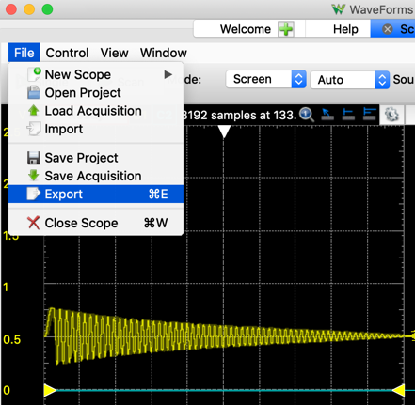
Under File, click Export

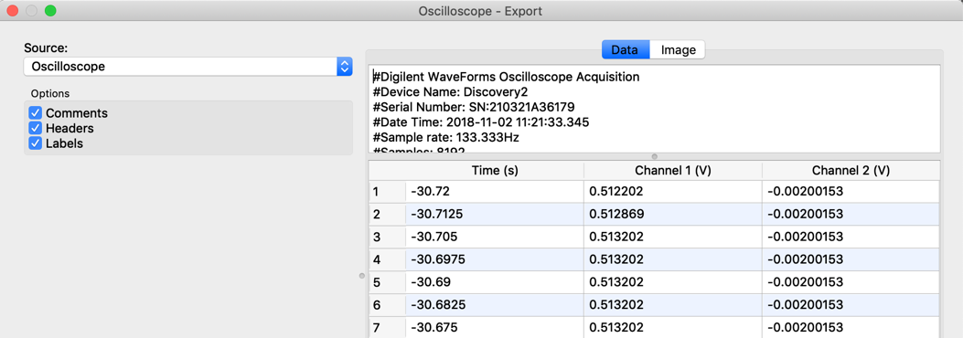
Source: Oscilloscope

Note: Using Comments and Headers saves the acquisition conditions in the .csv file. BUT, you’ll need to strip out that information for plotting.
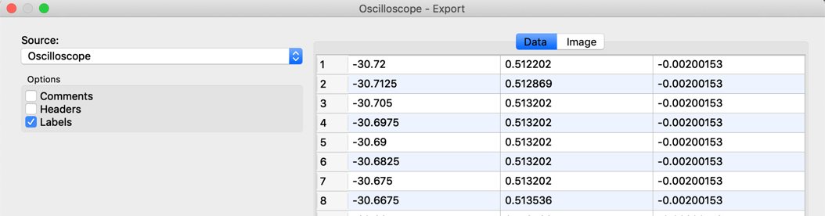
Deselect Comments and Headers.

Throughout the course you’ll be saving data files that you’ll want to access later.
Now is a good time to think about a folder structing and file naming convention.

- Plot and analyze data
Finally, let’s create our figures. The first figure will be your calibration data – measured angle versus measured voltage plotted as data points. This data was recorded by hand. Plot it using your program/language of choice (Excel, MATLAB, Python are all good choices). Examples of plots are found on the Canvas website.
You can now generate a calibration curve for V(θ). In this case, our “curve” is linear.
$y=m∙x+b$
In this situation, what is the independent variable (x)? What is dependent variable (y)?
When θ=0°, lug 2 should be touching the midpoint of the 10KΩ resistive tract.
What V_{out} do you expect when θ=0°?
Take a minute to try to write (or draw) the relationship between V, I and R.

You can find the approximate slope of the line, m, by inspection of your plot. You can test your calibration curve by overlaying the experimental data and the best fit line. There are formal ways to best fit a line through data, but for now you can just approximate by eye.
Now create the plot for your recorded pendulum dynamics. Please see the plotting examples on the ISIM website to see how to generate plots in MATLAB or Python.
- Create and submit the report
We are expecting to see a brief description of the lab, evidence, and your interpretation of the evidence. You can find general lab guidelines on the Canvas website (under Modules -> Course and Technical Resources -> iSIM Lab Report and Plotting Guide).
You DO NOT need to write a lengthy lab report each week. The lab reports focus on results.
For this lab, you should include:
Your calibration curve (𝜃 versus V_{out});
Your measured pendulum dynamics in terms of 𝜃 versus time;

For this lab the data are simple, so you do not need to provide very much commentary on the results. One page with two figures and a figure captions should be sufficient for your first lab. The figure caption should briefly explain what the figure is showing. For the plots, don’t forget to label your axis and provide units.

