Lab 10: Ultrasonic echo location
Parts list:
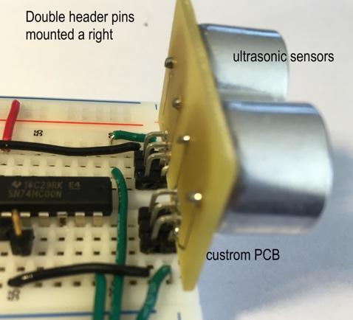
40 kHz ultrasonic sensors
PUI Audio, Inc, MFG P/N UR-1240K-TT-R
DigiKey P/N: 668-1546-ND
https://www.digikey.com/product-detail/en/pui-audio-inc/UR-1240K-TT-R/668-1546-ND/6071958

Right angle termination breakaway header pins, double row
Sullins P-E-0.100-36-D-BB-N (6 mm head, 5 mm tail)
Printed Circuit Board (by Blinded Name), design available via ________; https://www.customcircuitboards.com/

Alternative:
Adafruit Industries LLC, Ultrasonic Sensor, DigiKey P/N 1528-2711-ND
https://www.digikey.com/product-detail/en/adafruit-industries-llc/3942/1528-2711-ND/9658069

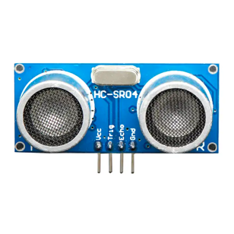
Image: Adafruit

