Problem set: Filters in series

What is this Pset about?
The world is noisy and it is hiding your signal. (Where did I put my little plastic chicken anyway?) But humans are clever and they invented tools to help you with this problem:
- We can choose whether we observe our signals in the time domain or frequency domain.
- We can design filter obstacle courses for our signal to reject unwanted frequencies, and allow our most precious plastic chicken frequency survive.
What do we hope you will be able to do?
- See how filters work in series and see how they behave at their limits
- Learn how to design a series of filters so that they function as if they were independent of one another
- Become more comfortable with the relationship between time, frequency, time constant, and RC, and the units we use when describing them
- Become more comfortable with ways to describe amplitude and relative amplitude, and the units we use to describe them

1. Build the circuit below. The circuit comprises two filters in series.
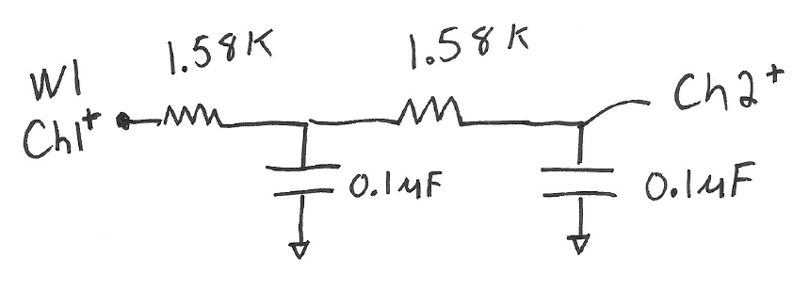
Draw a circle around each of filter. What kind of filter is each?

2. Connect the Discovery to your circuit.
Ensure the Discovery and circuit share a ground.
Use Wavegen 1 as the V_input signal.
Use Scope Channel 1 to monitor the input signal;
Use Scope Channel 2 to monitor the V dropped across the 2nd capacitor; we will consider this the filter output.
Where should you connect Channel1- and Channel2- in your circuit?
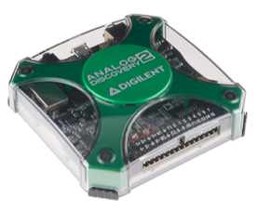

3. Add to collect an experimental Bode plot
Your filter has a natural response time of RC.
What is its natural response frequency in Hz?
Chose Start and Stop frequencies that will allow you to see how this filter behaves far below and far above its natural response frequency.
Use “Single” to produce a single sweep.
Save the Bode plot data through the export feature.
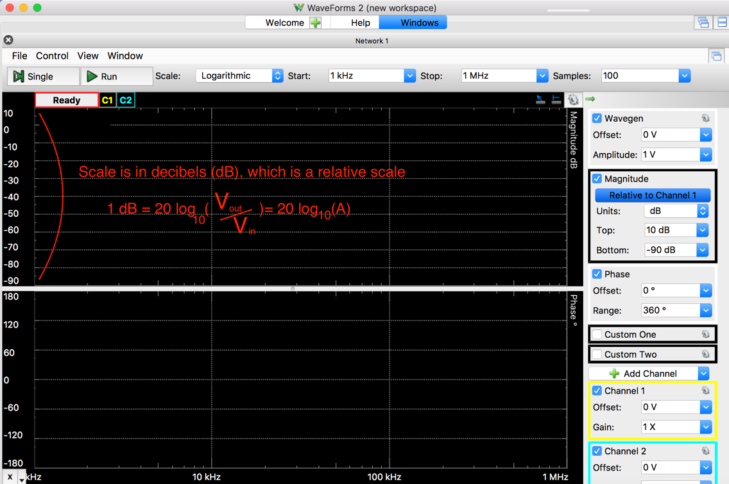

4. Compare the experimental results with the theoretical values
Recall that the amplitude of the output sine wave for a single filter of this type is:
$A(unitless)= \frac{1}{\sqrt{1+{\left(RCω\right)}^{2}}}$

$ϕ(radians)=(-RCω)$

When we have two of these filters in series with no current flow between them, then the amplitudes multiply and the phases add, namely the ideal response for 2 of these filters in series would be
Analytical
(theoretical) model

$A= \frac{1}{1+{\left(RCω\right)}^{2}}$

$ϕ=\left(-RCω\right)$
Compare your experimental Bode plot results to the prediction.
To compare A(theory) to A(measured), what units should you use?
How do you convert from dB to a unitless ratio or vice versa?

5. Change the R & C values and generate the Bode plot.
Now change the circuit as follows.
How is this circuit different from the first?

What is the natural frequency of the second filter now?

Draw a dotted line around each filter. What type of

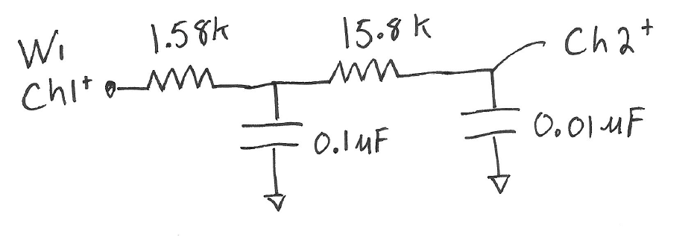
This strategy will tend to reduce the current flow from one filter to the next. This circuit should be a closer approximation to the ideal behavior where the two filters in series act as though they were each independent.
Create the experimental Bode plot and export the data.
6. Swap the position of the two filters (now the 15.8k and 0.01 μF filter comes first) and generate the Bode plot.
For your problem set, compare the behavior of these three circuits (Step 4, 5, 6) to the theoretical model.

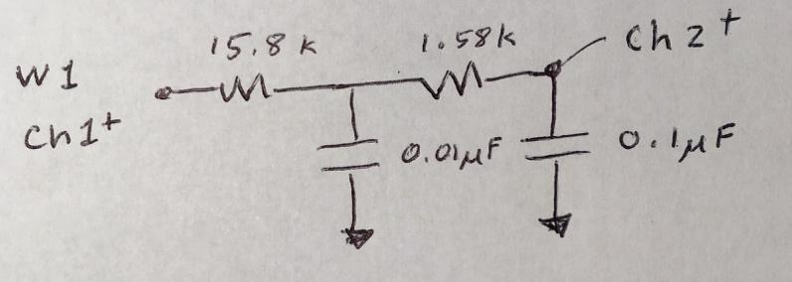
7. Try two different filters in series as shown.
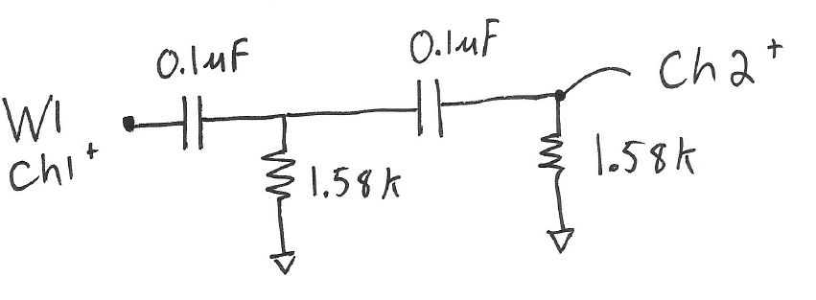
Draw a circle around each of filter. What kind of filter is each?

Generate and save the experimental Bode plot for the above circuit.
Like the two filters in series above, if these filters were acting independently of one another, we would simply square the equation for the amplitude, A, and sum the phase shifts of each filter.
What are the equations for A and 𝜙 of the filter shown in the circuit for Step 7?

For your problem set, compare the response of this circuit to the theoretical model.

8. Now try two low-pass and two high pass in series as shown below.
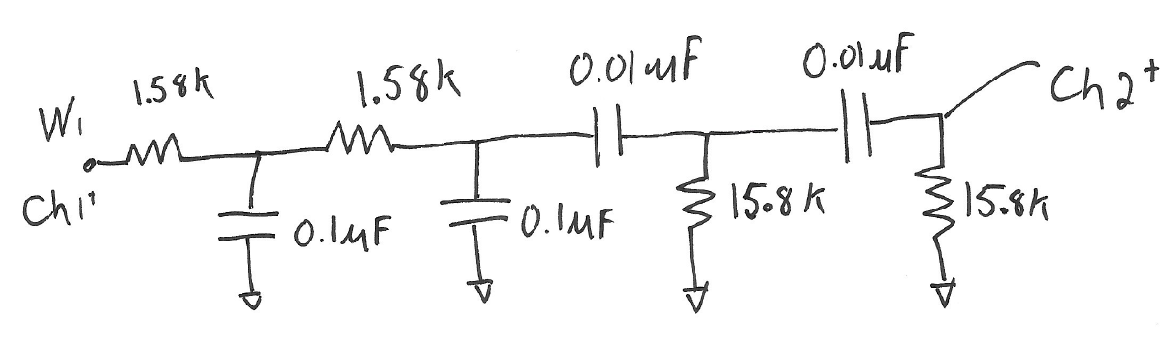
Generate and save the experimental Bode plot for the above circuit.
Note that if there were no current flow between the filters, the amplitude response would just be the product of the four independent filters.
For your problem set, compare the amplitude response of this circuit to the theoretical model.

Compare the experimental amplitude, A, plot to the ideal theory.
(You can ignore the phase relationship. )
Deliverables
For this assignment, turn in a bunch of Bode plots. All your plots should be clear, have axis labeled and have a short caption for each one so we know what circuit corresponds to what data and whether the data is a measurement, analytical expression or both.

