Lab 6: Using bandpass filters to detect blood pressure

Goal: Design and test a bandpass filter that can isolate a blood pressure signal.

This week you will design and build a system to estimate your mean arterial pressure (blood pressure). Typically a medical professional will measure the systolic and diastolic pressure. These pressures correspond to the maximum and minimum pressures in the arteries when the heart beats.
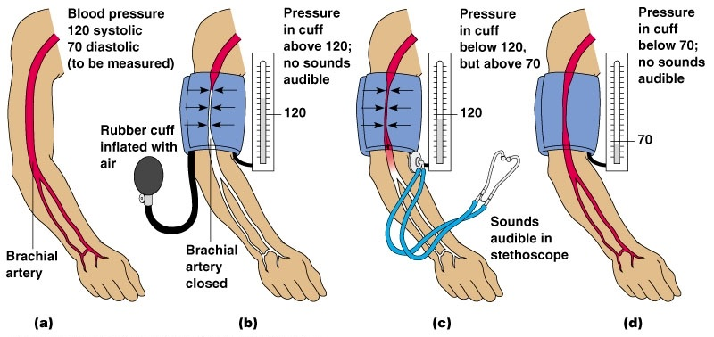
Source:www.3.bp.blogspot.com

High blood pressure is a risk factor for a number of diseases, thus blood pressure monitoring is one of the most common measurements in health care. Many of the automated blood pressure machines that you see for sale at the pharmacy don’t measure pressures directly, but calculate these pressures empirically from the resulting oscillations in your pulse.
The simplest oscillometric technique is as follows: If you inflate a cuff on your arm above the systolic pressure and then deflate the cuff, you will feel the pulse in your arm increase quite dramatically as the pressure is lowered.
If we monitor the total pressure on the cuff, we will see the overall decay of the pressure signal (Figure 1, left), but embedded in this decay is the small pressure change due to your pulse (Figure 1, right). In Figure 1 we show a raw trace of the cuff pressure and then a zoomed in version at a certain time.
Mark the points in the zoomed-in data (Fig. 1, right) that represent the heart pulse.
Approximately, what is the frequency of this pulse in Hz (cycles/second)?
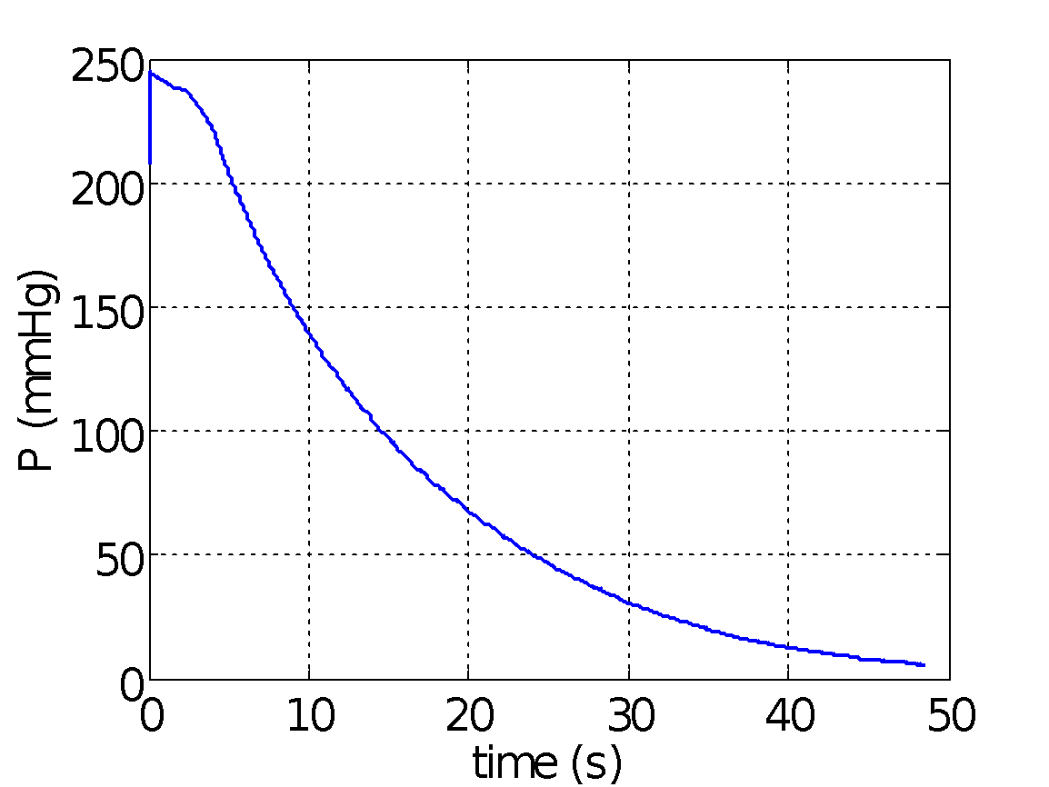 | 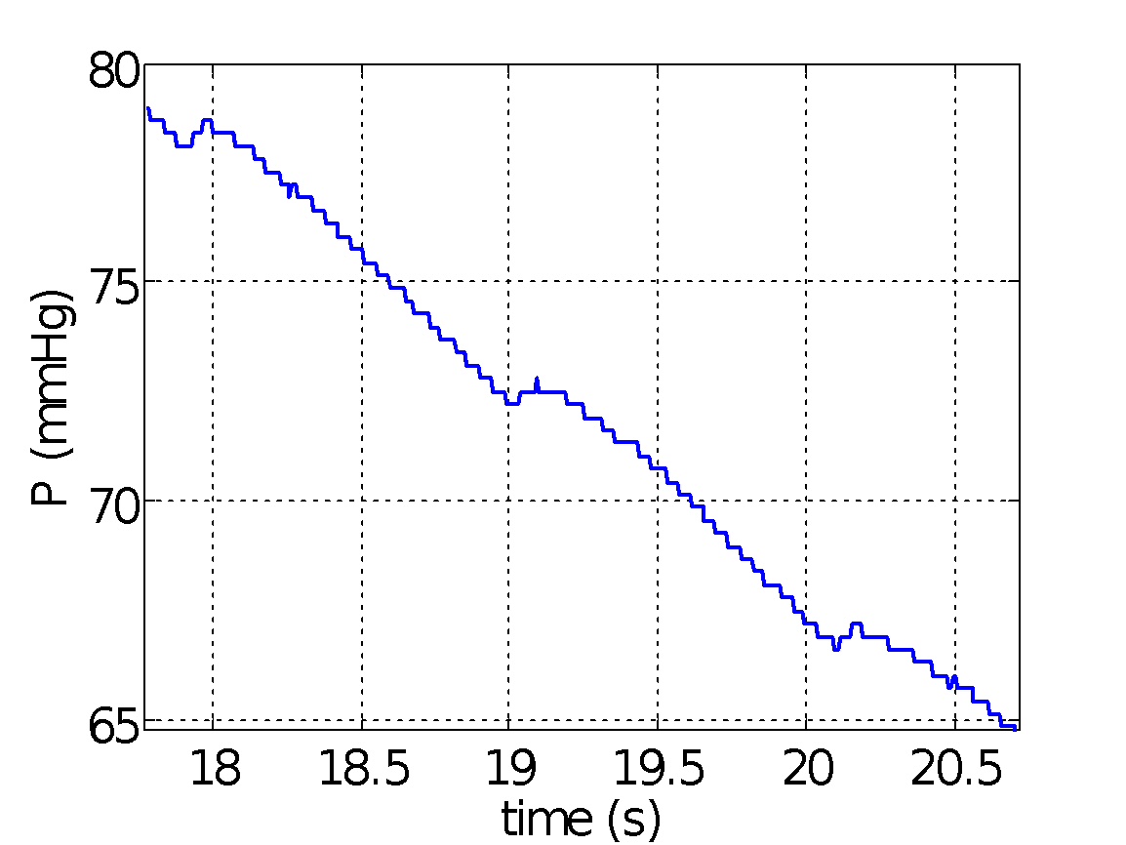
Figure 1: Raw pressure reading from blood pressure cuff (left)and zoomed in around a few seconds (right).
We can process the raw pressure signal to remove the slow decay.
What type of filter would we need for this?
Which of the circuits below could serve to remove the slow decay, if R and C were properly chosen?
We can process the raw pressure signal to remove the noise seen in the zoomed in data.
What type of filter would we need to do this?
What would you suggest for the cutoff frequency of the filter?

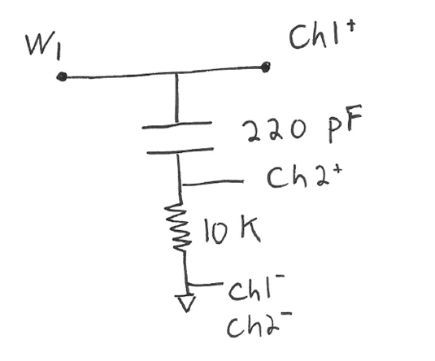
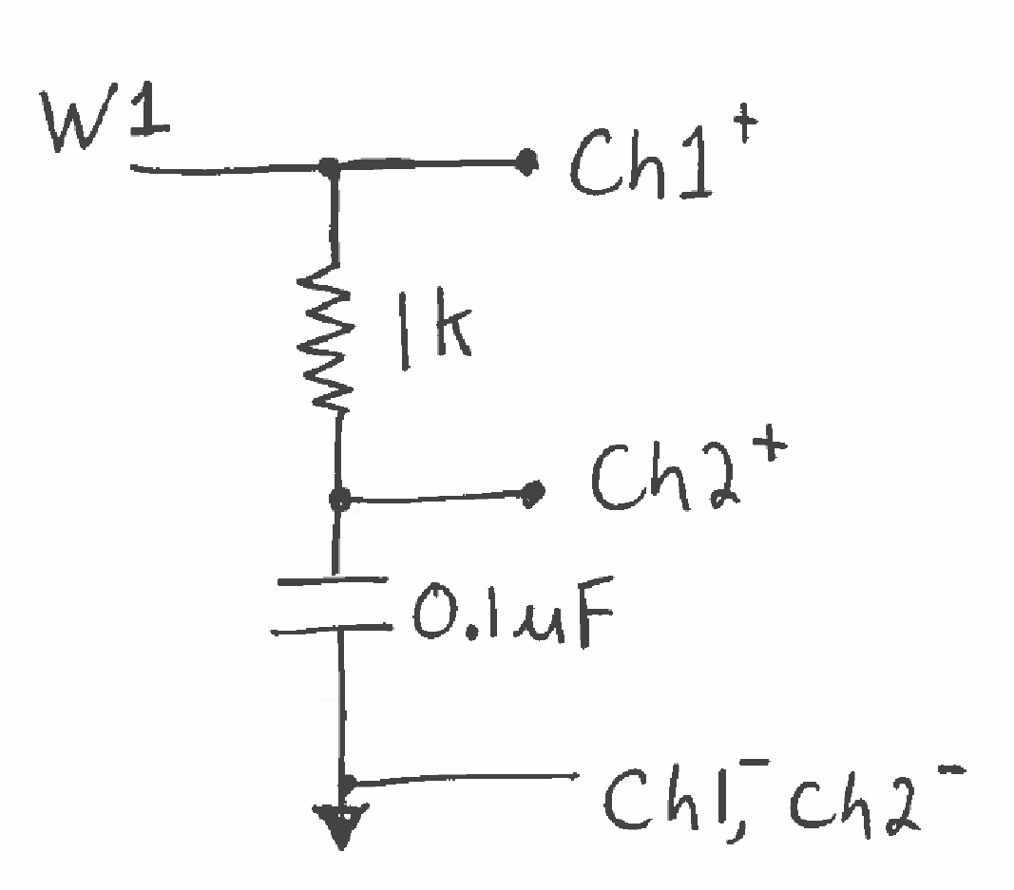
Filter circuits: Which filters out high frequency input? Which filters out low-frequency input?

Signal input
Signal input
filter output, Ch2⁺
filter output, Ch2⁺

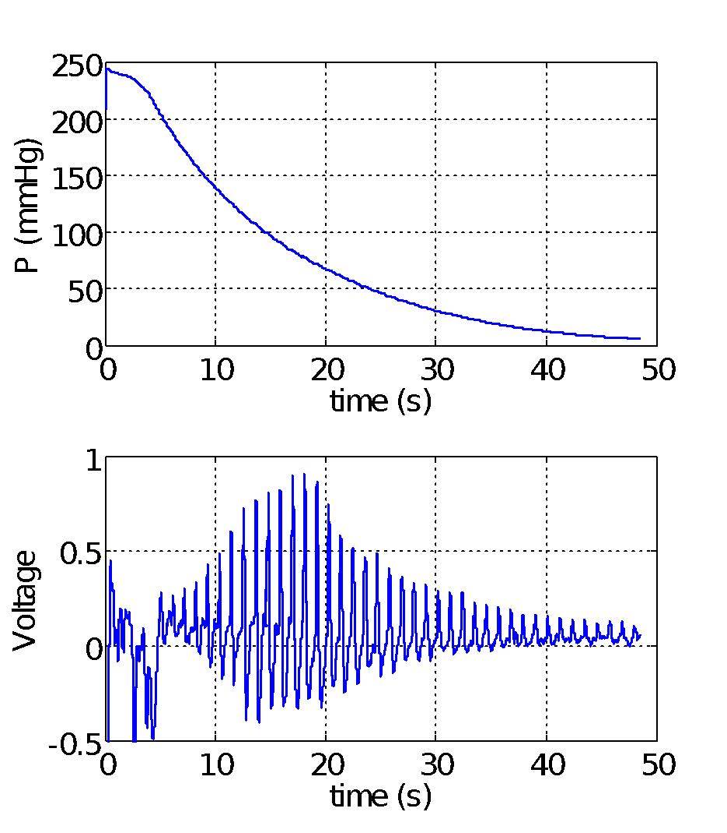
A processed signal is shown in Figure 2 (right), bottom.
upper signal = raw pressure signal
lower signal = processed signal
Look at the shared time axis.
In the lower signal, what causes each individual cycle?
The lower signal, Figure 2, is what you will feel during the measurement; your pulse intensifies and then decays.

Individual cycle
The pulse amplitude grows as the cuff pressure releases and more blood is able to enter your artery. The pulse amplitude decreases as your artery fills to its normal state. It is at the time when the pulse amplitude is maximum that we call that pressure the mean blood pressure.
Figure SEQ Figure \* ARABIC 2: Raw pressure signal and processed signal. (For this lab, you’ll turn in your own version of this figure.)

In this case, the pulse maximizes around 18 seconds. If we then look at the total cuff pressure at this time, we find the cuff pressure was about 78 mmHg. This value of the pressure is then assumed to be the mean arterial pressure.
The mean blood pressure is taken to be about 2/3 of the diastolic plus 1/3 of the systolic.
Disclaimer
We are not medical doctors.
Please don’t attempt to interpret anything other than your mean blood pressure.

Your privacy rights
The blood pressure plot could be construed as medical information protected under privacy laws. If you are AT ALL concerned about submitting your personal data with your lab report, YOU DO NOT HAVE TO DO SO. You may borrow one of the instructors who will happily serve as your data source if you wish.

- Obtain and upload blood pressure data to Wavegen
For your safety, we will input pressure data collected on one of your instructors to test your circuit performance.
While measuring your blood pressure is safe, measuring several times in a row is not a great idea.
The WaveGen can play back recorded data. To use this playback mode:
- Download the BPdata.csv file from isim.olin.edu.
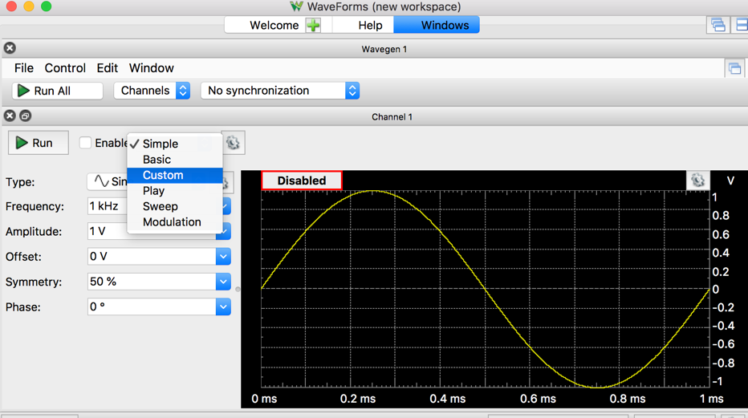
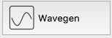
- In Waveforms add

- Next to the Run button, pull the drop down menu and select “custom”.

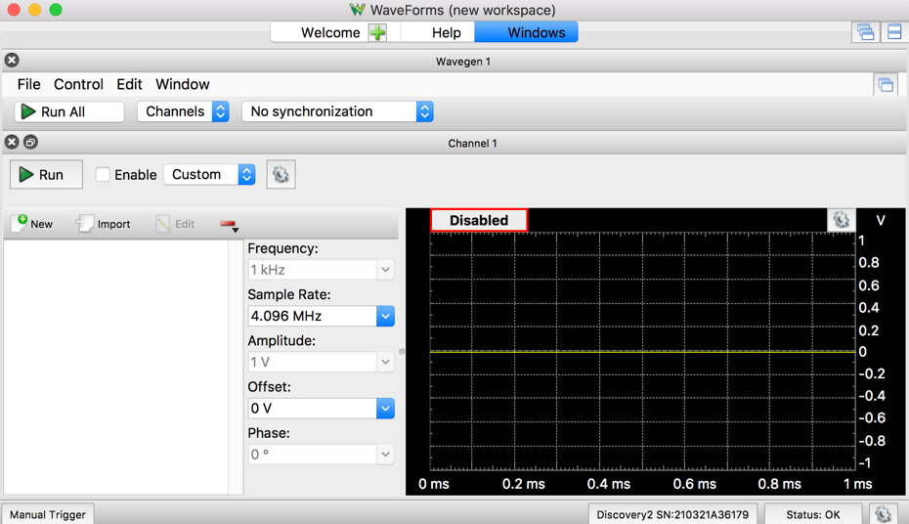

- Click import.

- Select the BPdata.csv file from your saved directory.

- Click Ok.
- Set the frequency to 16.6 mHz or 0.0166 Hz. This will change the signal to repeat every minute (the rate it was recorded).

- ►Run

- Connect the wire for Ch1+ to the wire for W1 and the wire for Ch1- to the analog discovery GND.

- Verify the blood pressure data with SCOPE
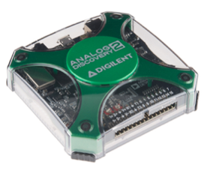
Connect the Discovery Ch1- & Ch2- to GRND; Connect circuit to GRND
Use Wavegen 1 as the V_input
Use Scope Channel 1 to monitor V_input;

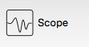
- Add

- Set the Scope time “Base:” to 6s/div and the Ch1 “Range:” to 1 V/div.
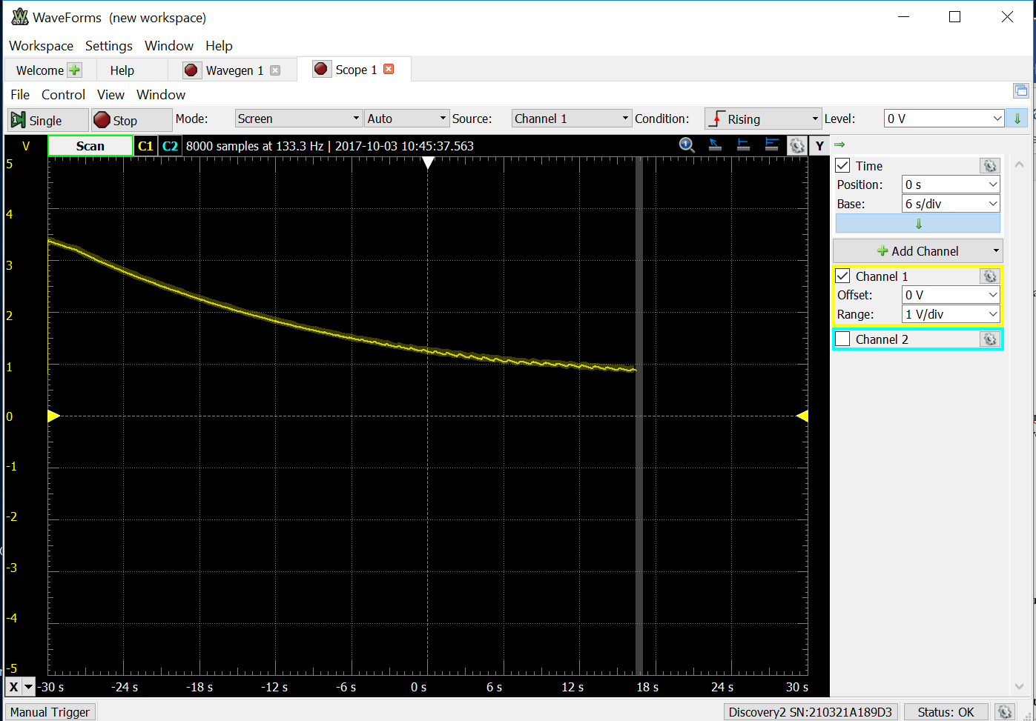
- ►Run

- Confirm that W1 is outputting the saved blood pressure cuff voltage data.
Figure 3: Actual data from the pressure sensor played back on WaveGen.

If you get a reading like Figure 3, you’re ready to proceed. You will use this data as the input to your circuit; it will help you ensure your circuit is functioning before you take your own data.
- Design the RC filters for your circuit
Use the circuit model below to design the filtering circuit that will remove the unwanted slow decay and the noise from the input signal. (After you verify that your circuit functions properly using W1 as input, you will replace W1 with the V_{out} from the digital pressure sensor, the MPX5050DP . )
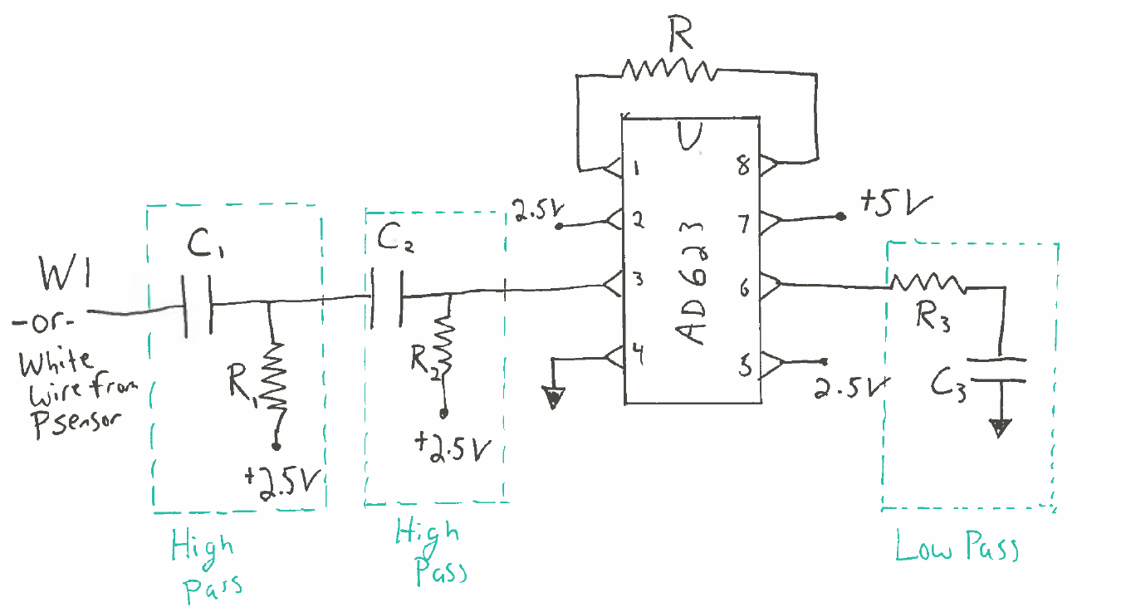
Where is V_{out}?
That is, determine the values needed for C1, C2, C3 and R, R1, R2 and R3.
The slow decay has frequency < 0.2 Hz.
If you were to draw an approximate Bode amplitude plot for an effective filter this application, what would it look like?
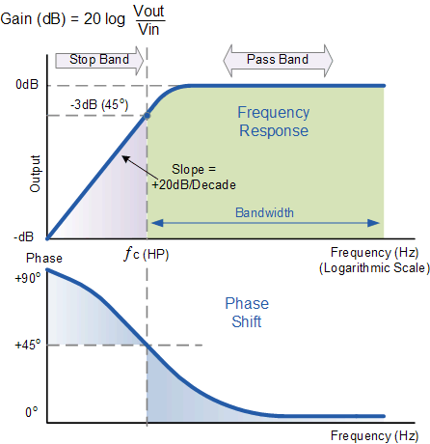
Remember, to compute the cutoff frequency of a filter, $ω^{*}= \frac{1}{RC} and f\left(Hz\right)= \frac{ω}{2π}$

*If ω is in “radians/second,” and RC is in “seconds”, how does this equation work out in the units?
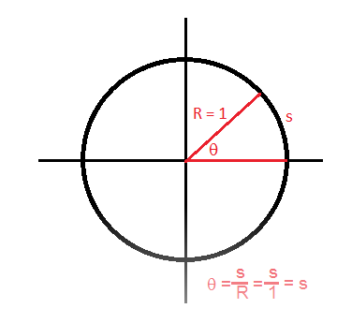
I’m glad you asked that. A radian is the angle, θ, within a unit circle, R=1, that produces an arc length, s=1:

$1 rad=\frac{s}{R}=\frac{1 unit length}{1 unit length}=1$
In other words, a radian has no units.
Since the slow decay and the pulse are not that widely separated in time scales, it is useful to have a strong high-pass filter – second order or higher.
A second order high pass filter means that for every factor of 10 in frequency you go below the cutoff frequency, you get a factor of 100 decrease in amplitude. You can get a second order high pass filter by simply chaining two normal RC high pass filters in a series.
Note that there is a range of cutoff frequencies that will work well, so maybe try a few different values and see what you like.
After the high pass filters, you should then amplify the result such that you get a reasonable level for the output signal. We found an amplifier gain of about 25 worked well.
You can experiment with the gain that gives you a good result.
- Build, test and debug your circuit
To build and debug the circuit it is best to build and test as you go.
Leave W1 playing continuously and monitor the output as you build complexity.
You are trying to get an output that looks similar to Figure 2.
How can I test parts of the circuit using Ch1+ and Ch2+?
Where in the circuit do I know what to expect from the output?
A voltmeter has a R_{internal}~10MΩ, while Analog Discover has R_{internal}~1 MΩ…when does R_{internal} become a problem in my measurements?
Once I know my circuit is working, where in the circuit should I measure V_{out}?

- Final data collection on you or a lab instructor
If you would like to test your system in real-time on yourself, get one of the blood pressure cuffs. If you don’t want to test on yourself, that is fine and you can just use the playback data.
Warning: Blood pressure measurement is routine. However, note that when you take the measurement you shut off arterial flow to your arm. Therefore:

- Please ask one of the instructors to show you how to work the blood pressure cuff if there is any question after the demo we will do in lab.
- DO NOT continue to repeat the experiment over and over again. You also don’t need to over pressurize your arm to a very high cuff pressure. You can test everything without putting the cuff on your arm or by inflating on your arm to a low pressure. Once you have things working, one test should be sufficient to get your data.
- DO NOT leave the cuff inflated on your arm for any period of time. There is a release valve that you loosen to allow the pressure to release slowly.
- DO NOT sit around with the cuff on your arm while you work, even if it is uninflated. For a small number of people the cuffs can irritate your skin. It is OK, and perhaps even recommended to have the cuff over your shirt sleeves.
- If anything feels uncomfortable, STOP.

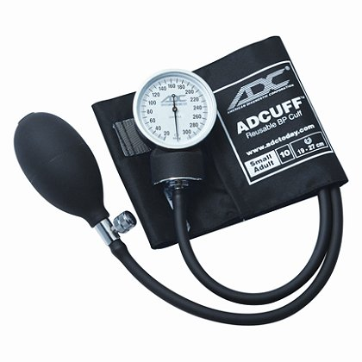
We will make our blood pressure measurements using a standard blood pressure cuff; however we have replaced the dial pressure gauge with a digital pressure sensor, the MPX5050DP
Connect the sensor to your circuit. Page 5 of the specification sheet provides the recommended circuit coupling (Figure 4*):
V_{s} = wire to _____________

GND = wire to _____________

V_{out} = wire to _____________

*The capacitors from Fig. 4 will not be needed.
Figure 2 shows the TRANSFER FUNCTION of the sensor. The pressure units in the TRANSFER FUNCTION are kPa. (For the Report, you will compute the pressure.) Write the equation for the TRANSFER FUNCTION:
To convert to mmHg, this information should be helpful: 1 atmosphere = 101.325 kPa = 760 mm Hg
Before testing on your arm, close the valve on the cuff, pump some air in, and press on the cuff to make sure the pressure signal is responding. Once it is responding it may be helpful to have a volunteer (i.e. one of your friends or an instructor) help you.
- Set the scope to 6s/div.
- Put the cuff around your arm.
- Close the valve.
- Run the scope.
- Pump up until the cuff is tight – you don’t have to overdo it!
- Stop and restart the scope so you get a clean screen.
- Release the valve very slightly.
- Hold as still as possible.
- Let the cuff fully deflate.
- Stop the scope and export the data.
- Create a Bode amplitude plot
You will want to confirm that your final circuit is working as you expect by creating a Bode plot. Since we are operating at low frequencies, the network analyzer will take a very long time to create the Bode plot automatically, so let’s record the amplitude part of the Bode plot by hand.
Disconnect the pressure gauge.
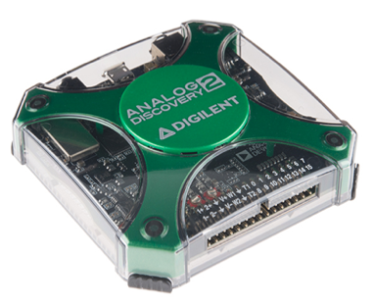
Ensure the Discovery and circuit share a ground.
Use Wavegen 1 as the V_input
Use Scope Channel 1 to monitor V_input;
Use Scope Channel 2 to monitor the V_out.

- In Waveforms, set the WaveGen for W1 back to “simple” and set to be a pure sine wave.
- Set the amplitude to 100 mV. Set the frequency to 1 Hz, just to get started.
- Put Ch1 onto the input of your circuit (where the W1 wire is) and Ch2 on the output of the circuit. Ch2 should be measured relative to 2.5V.
- Add SCOPE; ►Run (Mode: Screen, Auto)
- Set the time scale to be 1 s/div
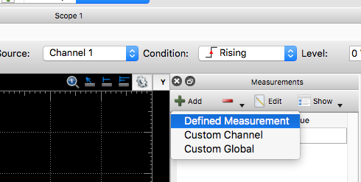
- Add a measurement of the amplitude of both Ch1 and Ch2.
  - View>Measurements
  - Add>Define Measurement
  - Channel (1/2)>Vertical>Amplitude

- In WaveGen, adjust the frequency and write your measured numbers down in the following table.
Frequency | Amplitude Ch1 (should be constant) | Amplitude Ch2
  - Hz
0.2 Hz
0.5 Hz
1 Hz
2 Hz
5 Hz
10 Hz
50 Hz
100 Hz
Deliverables
For this lab, you should include:
- Your final circuit schematic (can be drawn by hand). Denote the values of the resistors and capacitors that you used.
- A very short explanation of the overall circuit and explain the cutoff frequencies and gain that you used. Explain why the resistors on the two high-pass filters are connected to 2.5 V.
- Data for the final BP measurement. Your version of figure 2. You may want to include the playback data as well as your own measurement if you took both.
- Generate a Bode plot (Vout/Vin v. frequency (Hz)) of the whole circuit you designed from the data in the table above. Annotate your Bode plot to show the different cutoff frequencies you designed for are represented in the result. Your plot should have log-log axis. This plot will be generated from the date in the table above – if you wish to collect more data to get a cleaner Bode plot, that is great but the table data is sufficient.

