Lab: Controlling Current with Op-Amps
Goals: 1. Configure an op-amp as a buffer. 2. Use negative feedback of an op-amp to create a current source; Challenge: Verify the theoretical $V-I$ characteristics of a capacitor and a light-emitting diode using a controlled current.
Learning objectives
- Apply the operational principles of op-amps to a feedback circuit;
- Derive a mathematical relationship between V_{out} and V_{in} for a simple op-amp feedback circuit;
- Demonstrate the use of an op-amp in a circuit as fixed current source;

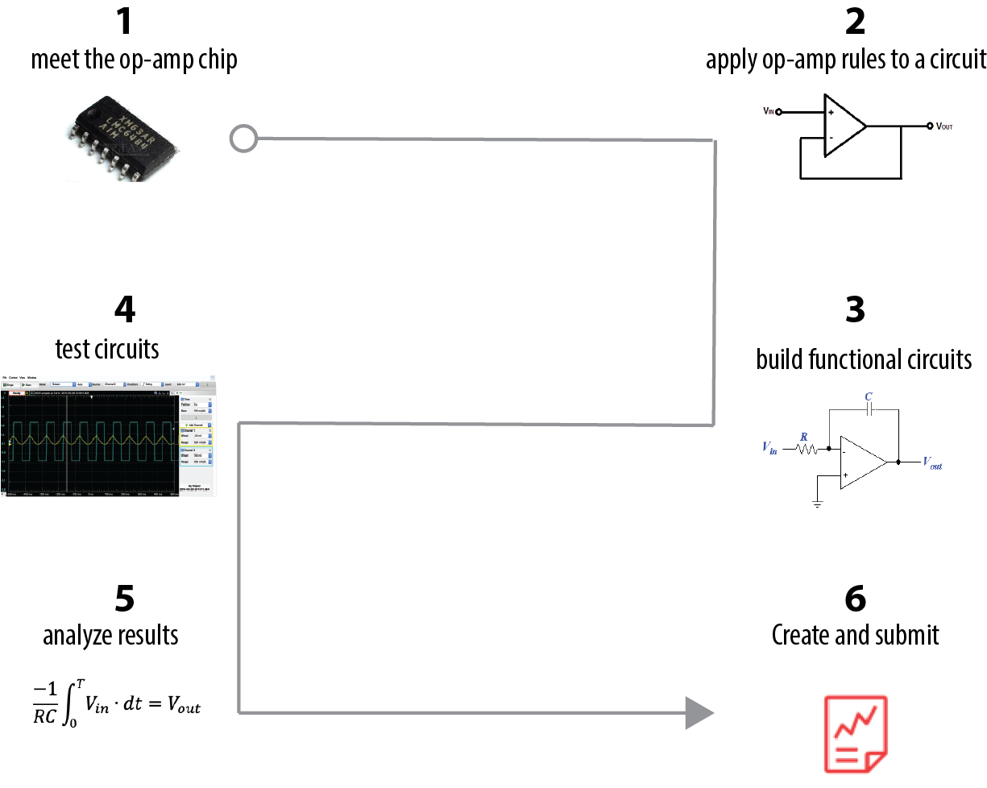

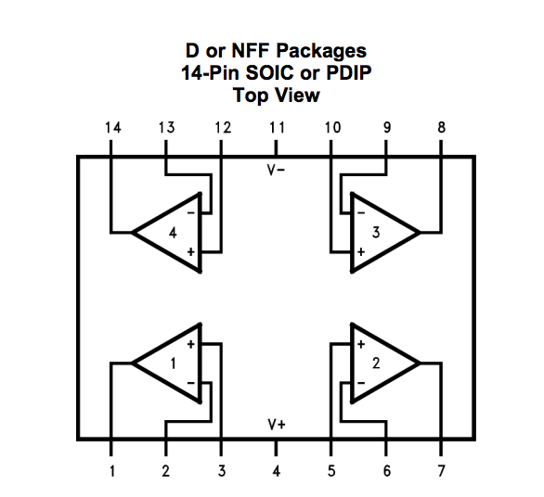
- Meet the op-amp chip

We will be using the LMC6484A op-amp chip which has the pin configuration schematic pictured to the right:
This schematic omits information. For example, all four of the op-amps are connected to $V_{s}^{+}$and $V_{s}^{-}$, which can be a range of values, according to the specification sheet from the above link. For this lab, connect $V_{s}^{+}$to +5V, and $V_{s}^{-}$ to ground.

An expanded, but simplified view of a single op-amp would look something like this:
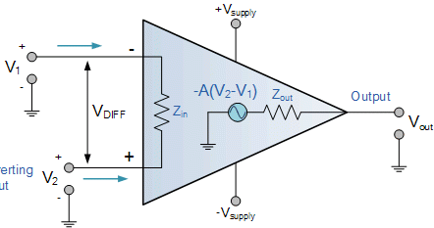

+
-
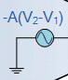
Image adapted from: https://www.electronics-tutorials.ws/opamp/opamp_1.html
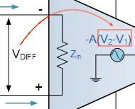
This expanded version helps us remember that the op-amp has an internal current source that enables it to push and pull electrons (i.e., supply ±I ) to the output pin, which it does in response to its differential voltage input, (V_{DIFF}).

The Z_{in} (internal impedance, see Problem Set 3) is so large that we assume that the input currents are negligible. We also assume that V_{out} instantaneously responds to the inputs.

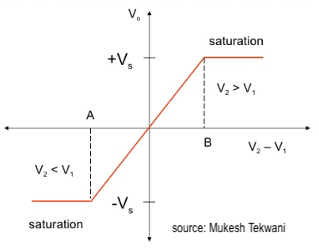
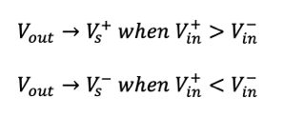
If you’re interested, you can check the specification sheet (LMC6484A) to see details of this internal current supply, such as gain (A), the maximum current that it can push and pull at the output, and that the range of V_{out} is When we use op-amps, we often “ignore” their internal components and their limitations—when you run into trouble with an op-amp performance, the trouble is likely to be traceable to these internal limitations.
Idealized op-amp behavior:
No input current

Infinite gain (A), causing

You are like an op-amp; your internal circuitry has limits. When you find that you’re not functioning as you expect, it is a good time to ask if you’re forgetting your internal needs and limits, such as rest, nutrition and exercise.

- Build and test a buffer
Use that same spec sheet to build a “Single-ended unity gain buffer” (Spec Sheet, p. 1), with 5V=$V_{s}^{+}$. The 0.1μF capacitor mentioned in the spec sheet on the $V_{s}^{+}$eliminates noise; you can skip it. A “buffer” is something that prevents one thing from affecting another: friendship can be a buffer against loneliness.
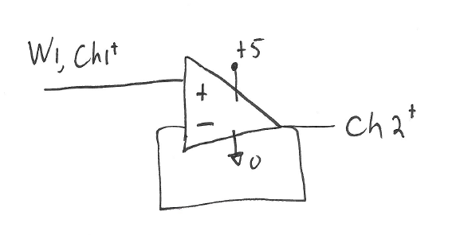

What is being buffered in this circuit?
(The answer will be useful.)

Using our principles of op-amps with feedback,
I₊= I ₋≈0, V+=V-
derive the expected relationship between V_{out} (Ch2⁺ in the diagram above) and V_{in} (Ch1⁺)
This op-amp feedback configuration has another name that directly describes how it functions.
What is its alternative name?

- Build a current source using op Amps
A useful circuit for exploring the relationship between voltage and current is shown in Figure 1. Please build this circuit, using any resistor or a small capacitor for the “black box.”
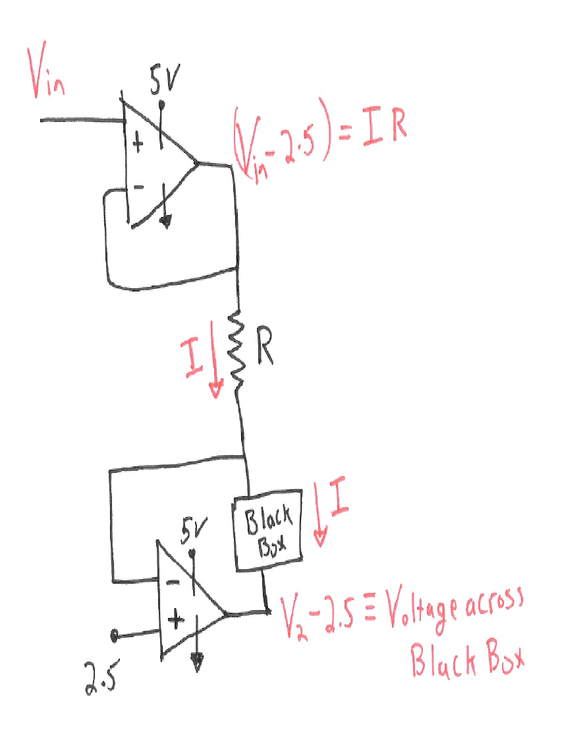

Draw a boundary around any op-amp to the left that is wired in “negative feedback.”

V

Any analog component, like a resistor, capacitor, or LED.

Figure 1: Generic source current, measure voltage circuit.
First, let’s try to understand this general circuit using our rules when op-amps are wired in negative feedback:

V
- $I_{in}^{+}=I_{in}^{-}≈0$
- $V_{in}^{+}=V_{in}^{-}$
Applying , determine the voltages at the following colored nodes?

Write the values on the circuit schematic.

Applying , write an equation for I and for

By controlling $V_{in}^{+}$and selecting an appropriate value of R, we can control $I_{BlackBox}$—we’ve made a current source!
- Test the source with a capacitor
- Build the circuit shown Figure 2a) using the LMC6484A chip which has the pin configuration pictured in Figure 2b). You might want to redraw 2a) using 2b) before you build it.
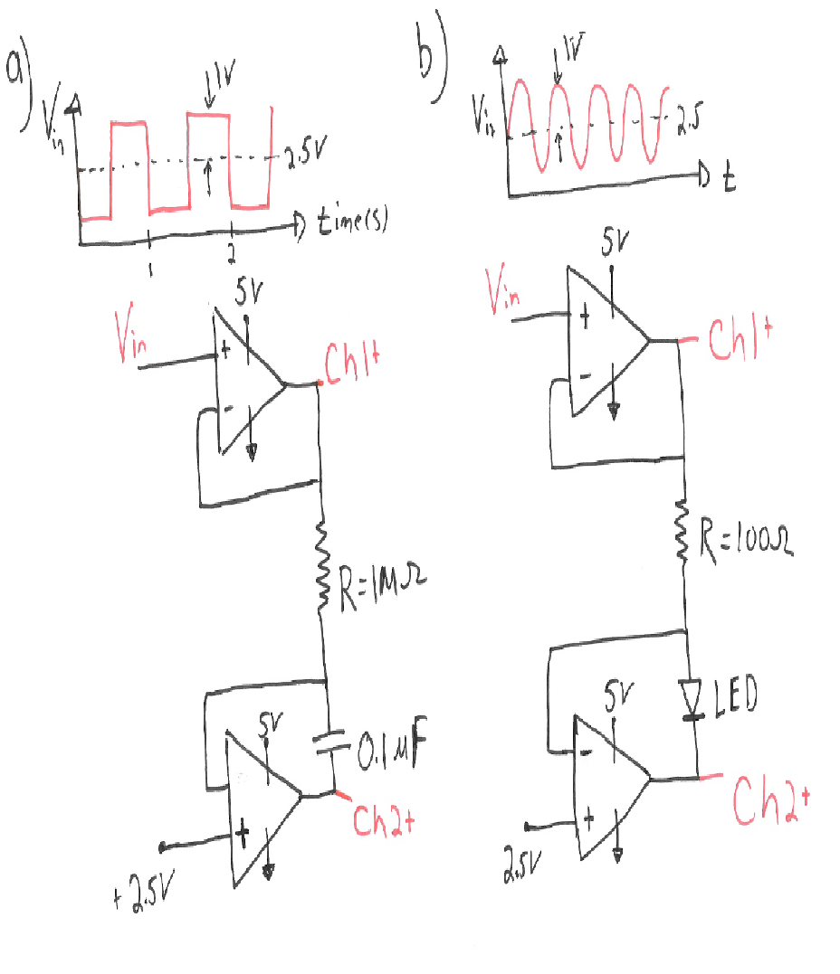

Figure 2. a) Circuit to test the capacitor performance, b) Pin configuration of LMC6484A chip.

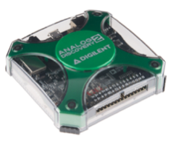
- Connect the Analog Discovery to the circuit; Set Wavegen using the V_{in} signal of Figure 2a).
Ensure the Discovery GROUND and the op-amp GROUND ( are equal.
Use Wavegen 1 as the
Use Scope Channels 1 & 2 as shown;
Your reference voltage is +2.5V.
Where do you connect and ?

- Assess the expected voltage across the capacitor:
Acts like a voltage source
The top op-amp forces a current through the capacitor:

You can think of current as charged particles flowing in time, in fact, 1 Amp = 1 Coulomb of charge /second.
What does the capacitor do with

To see if you’re getting the output that you expect, we’ll have to recall that
$I_{capacitor}=c∙\frac{dV}{dt}$ ,
where c is the capacitance of the capacitor and $\frac{dV}{dt}$ is the change in voltage across the capacitor with time.
For any ½ a cycle, I is constant
Let’s rearrange this equation and integrate:

$\frac{1}{c}\int{}I_{capacitor}dt=\int{}dV$
Remember V/R=I. And since the voltage is constant during the ½ cycle, we can take the current out of the integral,
What should V(t) v. t look like over the whole period
$\frac{\left(3.5-2.5\right)V}{cR}\int{}1dt=V\left(t\right)$
$\frac{1}{cR} t=V(t)$
Is your capacitor functioning as expected?

- Let’s verify the theoretical behavior of a capacitor, $\frac{dV}{dt}= \frac{1}{c}∙I_{capacitor}$
Using Wavegen, change $V_{in}$(therefore changing $I_{capacitor}$). Use 5 different $V_{in} {\left(all>0 V\right)}^{*}$and measure $\frac{dV}{dt}$across the capacitor. Fill in the table below.
$*remember that your chip, the LMC6484, can provide a maximum voltage output defined by the V_{s}^{-}and V_{s}^{+}.$
In choosing my range of V_{in} values, what is my V_{max}?

To measure $\frac{dV}{dt}$, use the vertical cursor tool on your dataset:
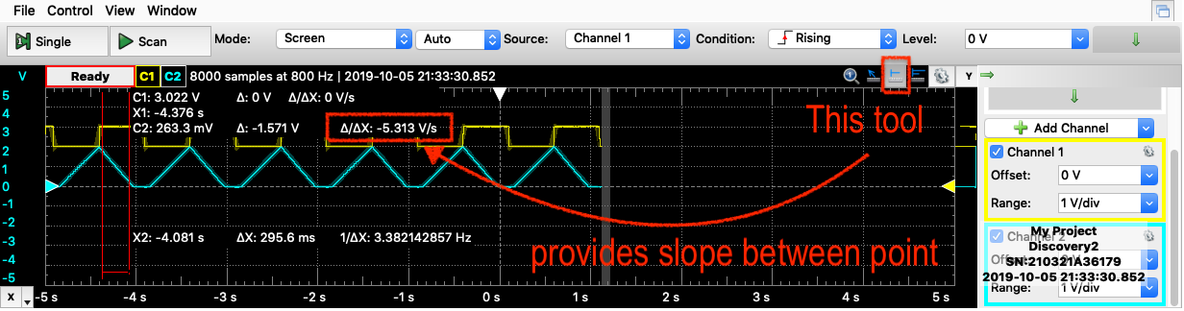

$V_{in}(Volts)$ | $\frac{dV}{dt}$ (measured) Volts/second

Did you verify our basic capacitor law, $\frac{dV}{dt}=\frac{1}{c}I$ ?
For your lab report, consult the lab report guidelines.
Include your data above and comment on whether your circuit is functioning as theorized.

Challenge: Verifying the I-V behavior of a light-emitting diode (optional)
- The second Black Box to test is a light emitting diode, LED. Build the circuit shown Figure 3.
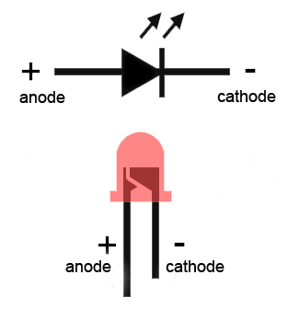
https://www.allaboutcircuits.com/tools/led-resistor-calculator/
Figure 3. Circuit using LED as Black Box.
- Connect the Analog Discovery and adjust the settings on Wavegen to V_{in} in Figure 3.
Ensure the Discovery GROUND and the op-amp GROUND ( are equal.
Use Wavegen 1 as the
Use Scope Channels 1 & 2 as shown;
Your reference voltage is +2.5V.
Where do you connect and ?

- On the scope, add an x-y plot. An idealized V-I curve for an LED looks something like this .
Which of Ch1 or Ch2 represents I ( y-axis)?

Does your plot make sense for an LED?

