PSet 7: Foundational Op-Amp Circuits
Goals: Learn how op-amps can be used to perform math operations on their inputs.
Learning objectives
- Apply the operational principles of op-amps to a feedback circuit;
- Derive mathematical relationships between V_{out} and V_{in} for simple op-amp feedback circuits;
- Formulate a name for the op-amp circuit blocks, based on your derived equations;
- Investigate the difference in V_{out} when tying the op-amp input reference to 2.5V v. 0V;
- Critique the benefit of using 2.5V v. 0V as an op-amp input reference.
Turn in these pages when you’re done.
The following op-amp circuits function. We invite you to determine how each circuit functions and formulate a name for the function.
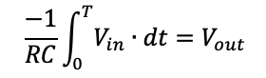
As an example, an integrator would produce a mathematical function that integrates the input:

Your goal is to derive an equation that relates the inputs to the output. To get started, apply the rules for op-amps in feedback and use Ohm’s law to figure out the current flow through each resistor.
- Inputs to the op-amp have zero current.
- V+=V- when we have negative feedback.
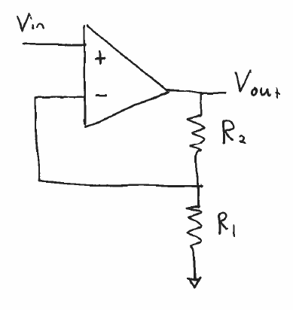 | $V_{out}=$  Name:
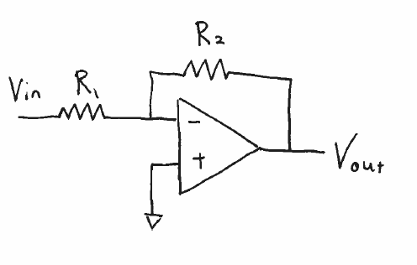 | $V_{out}=$  Name:
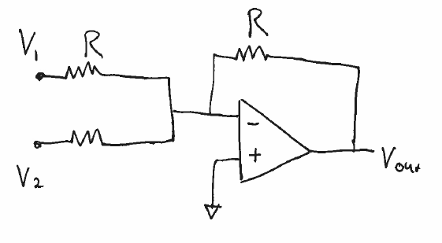  R | $V_{out}=$  Name:
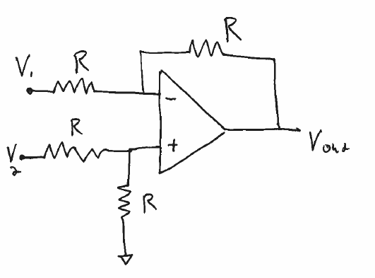 | $V_{out}=$  Name
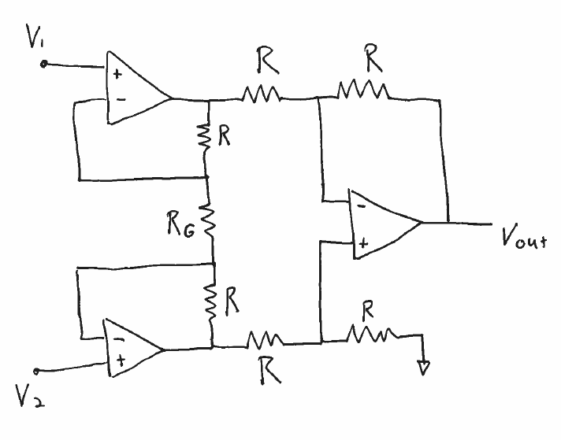 | This is the challenge circuit  $V_{out}=$  Name: Instrumentation amplifier

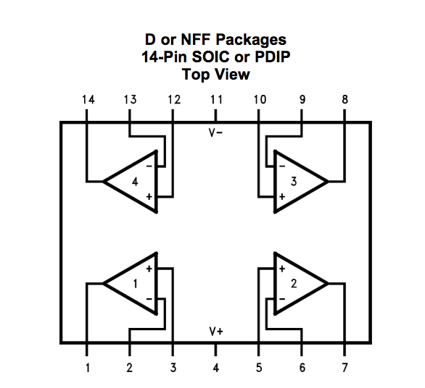
Now we ask you to evaluate two different op-amp configurations as shown in the figure below through measurements. You’ll need a LMC6484 chip and an Analog Discovery. Build both circuits.

Set up the Scope to monitor V_{in} with Channel 1 and V_{out} with Channel 2.
Make sure you have configured your circuit and hardware so that your computer, your breadboard and the Analog Discovery share a 0V reference.

For the input, we suggest you use Wavegen to produce a 100mV sinusoidal voltage of 1kHz, offset by 2.5V (a) and then offset by 0V (b).

Work to understand how the difference of 2.5 volts or 0V changes the V_{out} response to the input of Figure a) versus in Figure b).
Explain any advantage of using 2.5V over 0V for these circuit configurations. There is no need to provide plots, just your thoughts.

