Problem Set 8: Complex Numbers

Goal: Become familiar with math operations using complex numbers; see how complex numbers can be used to show the frequency response of an RC circuit.
Note: This PSet will be much easier if you have already watched the lectures on complex numbers.
Deliverable: This worksheet and two plots.
Part I: Basic Operations with complex numbers
For the following, take $z_{1}=1+j$ and $z_{2}= -3+4j$.
- Convert $z_{1}$and $z_{2}$ to polar and exponential notation (find $r, θ$).

- Plot $z_{1}$and $z_{2}$on the complex plane below.

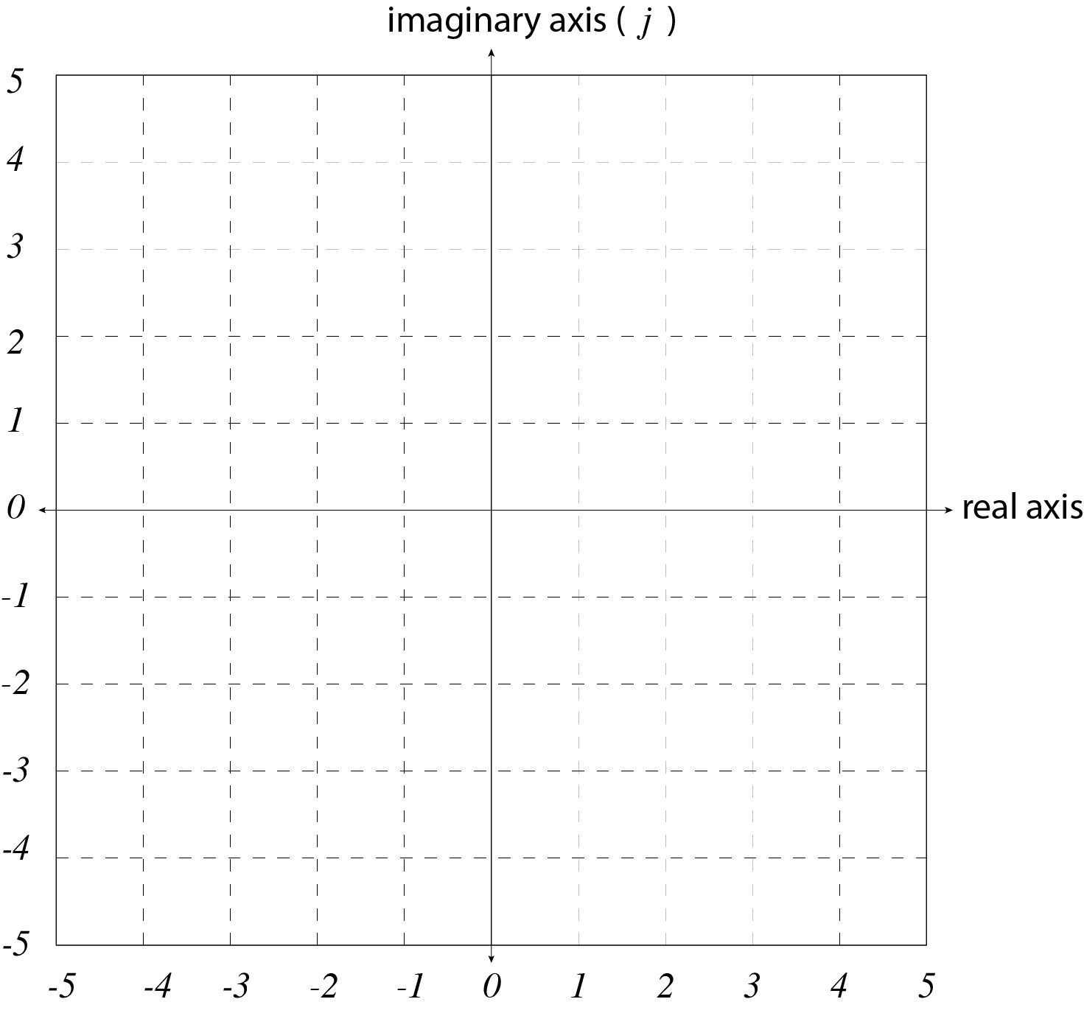
- Compute $z_{1}$+ $z_{2}$. Show $z_{1}$+ $z_{2}$. graphically on a plot in the complex plane from 2.

- Compute $z_{1}$- $z_{2}$. Show $z_{1}$- $z_{2}$. graphically on a plot in the complex plan from 2.

- Compute $z_{1}z_{2}$. Repeat the computation using a different notation.

- Compute $\frac{z_{1}}{z_{2}}$ using complex notation. Compute $\frac{z_{2}}{z_{1}}$and compare.

- Compute $z_{1}^{4}$
Part II: Plotting complex numbers
Complex numbers using polar notation are super useful for illustrating how a circuit responds to time-varying signals.

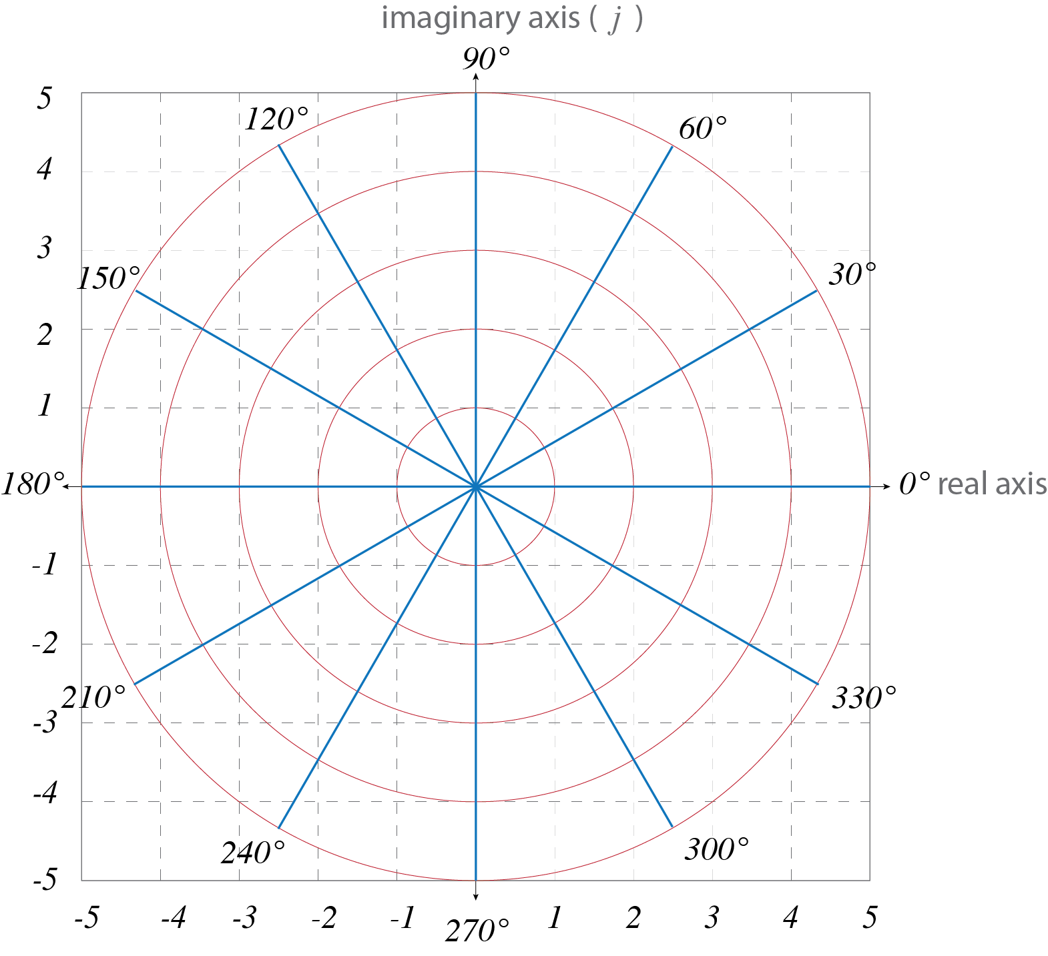
What does

look like?

A Wavegen input signal is a sine wave,

In r,𝛳 notation, what is its r ?

The polar coordinates (above grid of red & blue) make use of a special property of the exponential function when it operates on $j(=\sqrt{-1}$). You may have seen this function notated (equivalently) as:
$e^{jθ}$, $exp⁡(jθ)$, or $e^{iθ}$
where $θ$ represents an angle in radians (Recall that $π$radians = 180°).
The amazing property of $e^{jθ}$is known as Euler’s formula (section 6.3 in your book):
$e^{jθ}=coscos \left(θ\right) +jsin(θ)$

If varies with a frequency, , what would look like in time?

Click this link to see. There is more info on page 4 for those who are interested.
Recall from Figure 6.3 that if we represent our cosine voltage input to a low-pass filter with polar notation,
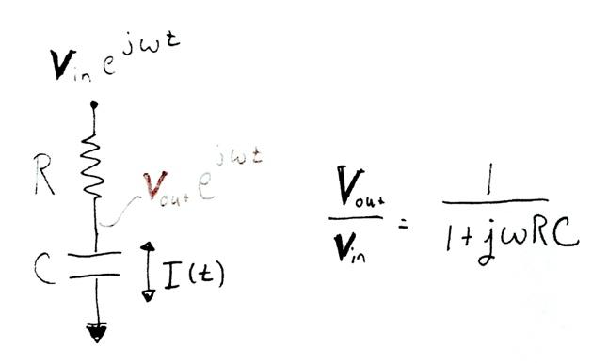
$V_{in}\left(t\right)=V_{in}∙e^{jωt}$
And $V_{in}$represents a complex number.

And remember that because the R and C are in series, the time varying current passing through both will be the same, we get,

$\frac{V_{in}(t)-V_{out}(t)}{R}=C\frac{{dV}_{out}(t)}{dt}$
and, rearranged a bit,
$V_{in}{∙e}^{jωt}-V_{out}{∙e}^{jωt}=RCjω{V_{out}∙e}^{jωt}$.
Or
solving for $\frac{V_{out}}{V_{in}}$ ,

Let’s let RC=1 second and $z_{3}=\frac{1}{1+jω}$

Convert z₃ and z₄ to r,𝛳 notation.
And $z_{4}=\frac{jω}{1+jω}$

Plot the magnitude of r of z₃ and z₄ as a function of ω on a log-log scale. Let ω* vary from 10⁻³ to 10³.
Plot 𝛳 in degrees for z₃ and z₄ as a function of ω on a semilog scale. Let ω vary from 10⁻³ to 10³.
Knowing that z₃ and z₄ represent the of low- and high-pass filters, what do you expect the graphs to look like?

*In Matlab, you can use the command:
y= logspace(-3,3)
to generate a logarithmically-spaced
vector, y, that spans 10⁻³ to 10³.
Watch vary as varies with a frequency,

Click this link to see.

These images illustrate for r=1,

at different points in time (
Real part, t=0
imaginary part,

