PSet 1: Resistors in series and parallel
Goal: Use a breadboard and resistors to measure how the resistance changes when resistors are connected in series and in parallel.
Learning objectives
- Describe the hidden wiring pattern beneath a breadboard;
- Use your power supply and breadboard to construct resistor circuits;
- Contrast theoretical voltages with measured values;
- Calculate the output of a voltage divider;
Looking ahead
- Measure the effect of the Analog Discovery’s internal impedance

Visual Summary
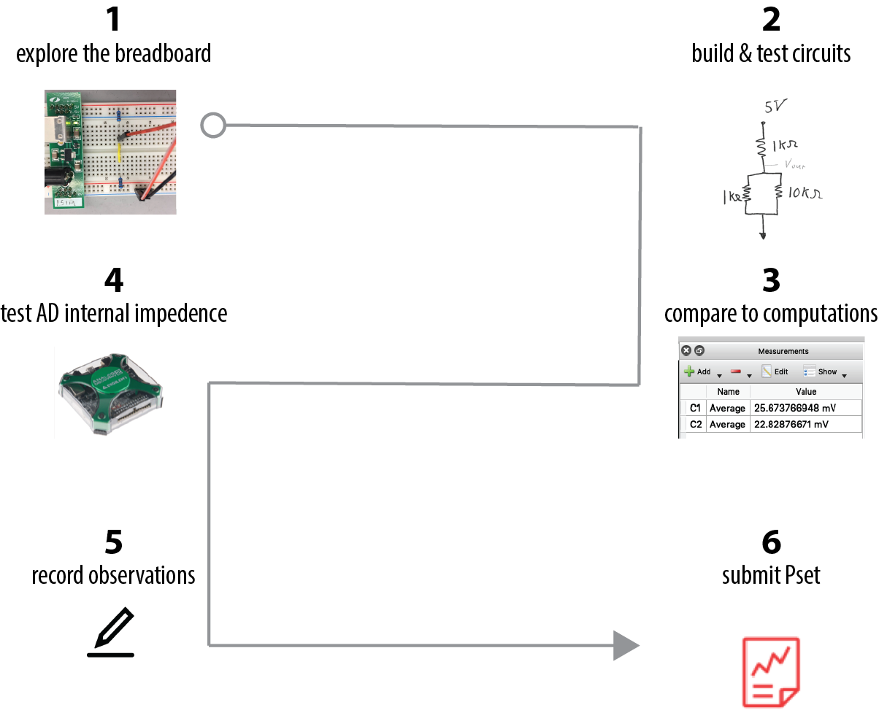

(looking ahead)

- Explore the breadboard
To get started this week, let’s use our breadboard and conduct a few very simple experiments with resistors.
The tutorial video on using the solderless breadboard explains how the basic connections work.
Below we show two equal resistors in series across 5 volts. Some of the hidden connections beneath the breadboard are indicated with the superimposed yellow lines.
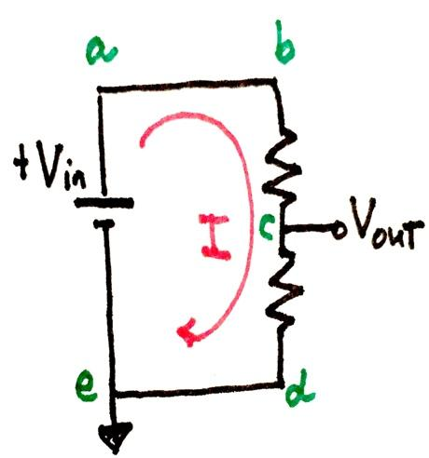
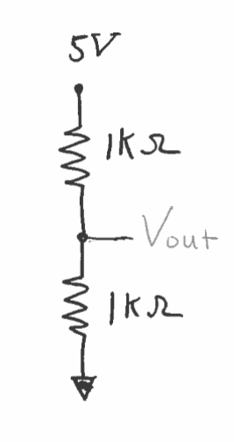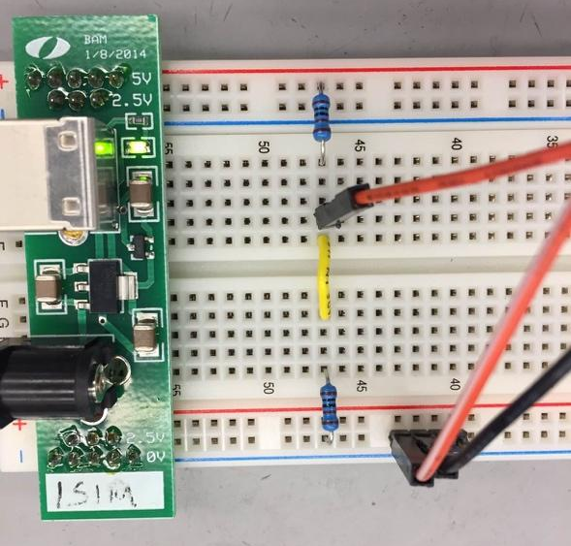
schematic
Ch1+
Ch1-
Ground
The two different schematics are equivalent ways of sketching the circuit. The schematic on the right reminds you that all the components are connected on a complete, closed path circuit where the current, I, flows. The one on the left is an easy reminder of our breadboard layout with the +5V breadboard “rail” and the 0V (↓ or Ground) breadboard “rail”.
In this case we are using your brand-new power supply to provide the constant +5 V.
In the image above, Ch1 will measure the ⁻. Which are true?
Ch1 = +V_{in} - V_{out} Ch1=V_{out} Ch1=V_{c}-V_{d}

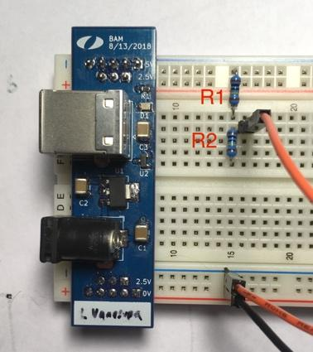
The circuit at the left is intended to be the same as above. R1=R2=1 k, but the voltage reading is nothing but noise.
Can you find the 5 errors?
1. The power supply is not plugged in; 2.R2 has both ends in the same row, which has the effect of wiring the resistor ends of R2 together, creating an electrical short; 3. The Ch1+ is not connected to the circuit; 4. The R1 and R2 are not electrically connect to the ground to complete the circuit; 5. Ch1- is connected to 2.5V rather than ground.
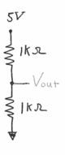
- Build & test the resistor circuits
Using your breadboard, and power supply and best practices, build the following circuit.
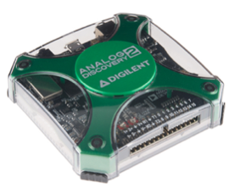
Attach the Analog Discovery (AD) to the circuit so that:
- Ch1+ measures V_{out} relative to Ground (this requires Ch1+ and Ch1- connections);
- AD, your breadboard circuit, computer & power supply share a common Ground.
Open Scope

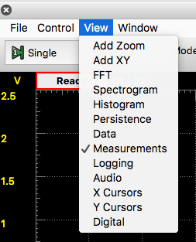
From View>Measurements, Add>Defined Measurement,

Channel 1>Vertical>Average
Scope computes a running average for the time window.

If the time window is too small or too large, the Average value will be distorted.

1 ms/div should be a sufficient time base.
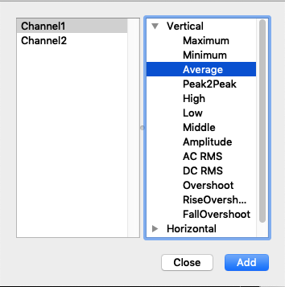
►Run
Assuming the power supply output is+ 5 V=V_{in} and each of the resistors are 1.0 kΩ, what idealized voltage do you expect for V_{out}?

Your V_{out} reading is likely to be different from the expected value.
Which, if any, of the assumptions about V_{in} or R values do not match reality?
How do the deviations from the ideal values affect V_{out}?

Now that you have the basic idea, analyze and construct each circuit in Table 1 and record the measured and expected voltage in the Table. Fill out the table on the following page.

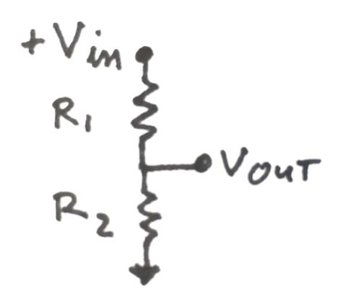
Each of the circuits in the table is a voltage divider. In each, the +5V_{in} “drops” over the top and bottom resistors, thereby dividing the voltage, V_{in}.
What is the correct equation for V_{out} for a voltage divider?
(Can you derive it? It may help to remember that the notation to the right is a shortcut for a circuit)

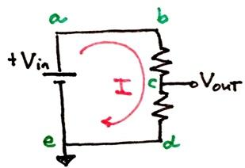

ΔV
I
R

Circuit | Expected V_{out} (include a short calculation) | Measured V_{out}
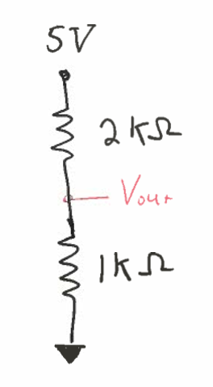
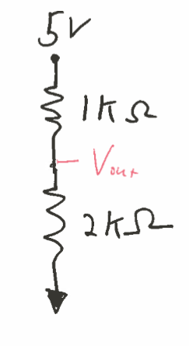
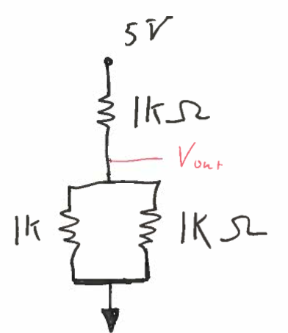
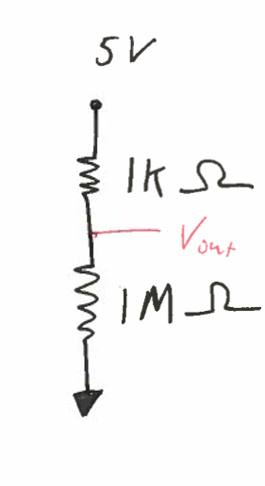
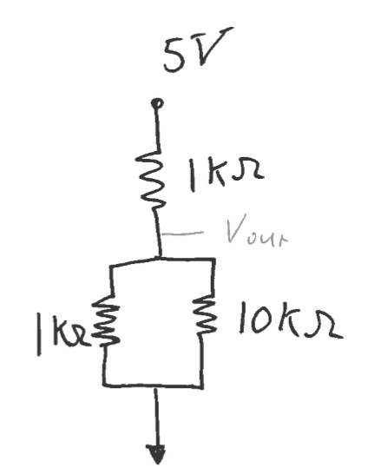

- Compare measured V_{out} to theoretical V_{out}
What patterns, if any, emerge from the results?
Talk to a colleague to compare your results and emergent patterns.

- Record your observations
Take a minute to record for yourself what you noticed.
This is for your own learning.

- Submit PSet
For these types of assignments you do not need to write a lab report. You can write your numbers in the tables and spaces provided. Please include supporting hand calculations.
These assignments are only checked for completeness – not fully corrected.
While anything you turn in should be neat and any analysis should be clear, you do not need to type anything up. You can just scan your hand-written work.
Also, many weeks you might not complete all questions as there is something you don’t understand. That is perfect. Just complete as much as you can, turn that in, and then come to next class with questions. These assignments are meant to be a bridge from the course content on circuits to the lab experiments.
You can always go back and complete and re-submit any of these assignments.

- (Optional: A look ahead at what we’ll do a few problem sets from now) Test the effect of the Analog Discovery’s internal impedance
Build and test the following three voltage dividers. All are the same basic circuit and in theory should give the same measured voltage - only the overall value of the resistor is changing.
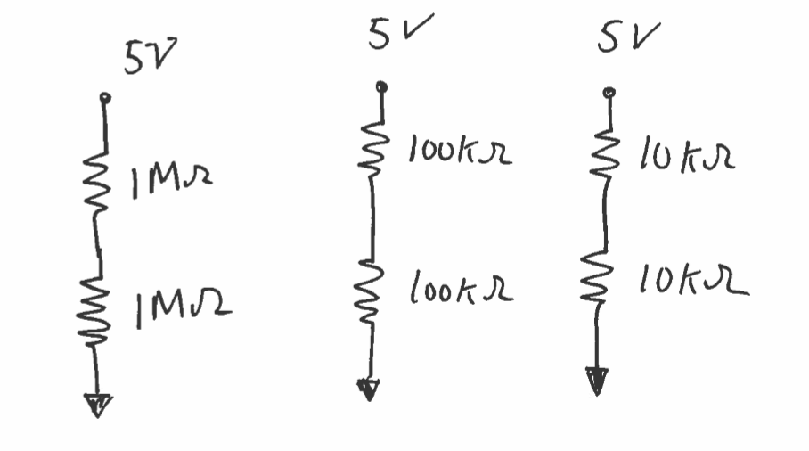
Circuit | Measured voltage between resistors
1M resistor
100K resistor
10 K resistor

Notice that while you might expect that all circuits would have the same voltage between the two resistors, this is not what you measure. The reason for the departure is that the measurement device has an internal resistance (“input impedance”-- see section 2.4 of the course book for an explanation), so that it acts as if you’ve added a resistor in parallel to the resistor that it is measuring.
From the three measurements infer the approximate value of the Analog Discovery’s input impedance/resistance. Include your calculation and measurements.
What value of input impedance for the Analog Discovery best explains your data?

Value of Analog Discovery input impedance (resistance):__________________________________

