PSet 2: Resistors in Series and Parallel
Goal: Learn how the total resistance changes when resistors are wired in series and in parallel.
Learning objectives
- Use your power supply and breadboard to construct resistor circuits;
- Apply Ohm’s law to a DC circuit;
- Contrast theoretical voltages with measured values;
- Compute the equivalent resistance of resistors wired in series and parallel;
- Operate a potentiometer
Just fill in your results on this work sheet (or rewrite) and scan your handwritten work in. Again, these types of assignments are simply checked for completeness.

- For the following circuit,
What kind of circuit is this?
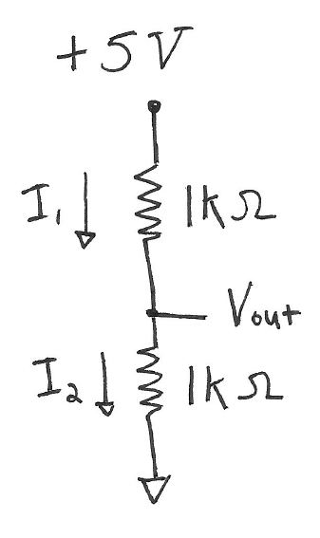
Please list the following (with units). V_{out} should be measured* relative to ground.

ΔV
I
R
- Vout (theory) =
- Vout(measured) =
- I₁ (calculated)=
- I₂ (calculated)=
*You may want to consult the class2 instructions for setting up the Analog Discovery.

- For the following circuit,
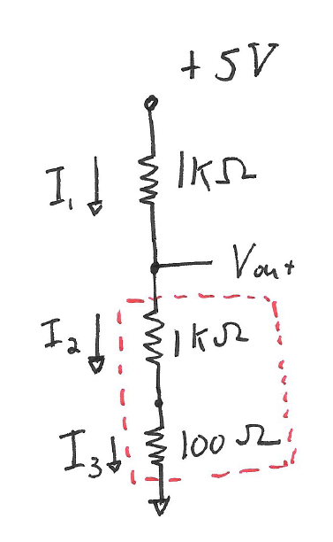
Please list the following (with units).
- Vout (theory) =
- Vout(measured) =
- I₁ (calculated)=
- I₂ (calculated)=
- I₂ (calculated)=

- For the previous circuit, we redraw with an equivalent circuit as follows:
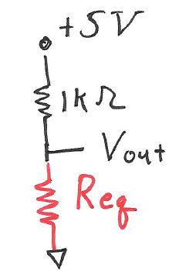
What is the value of a resistor that is the equivalent to the resistors in series (the red branch in question 2), R_{eq}?

- For the following circuit,

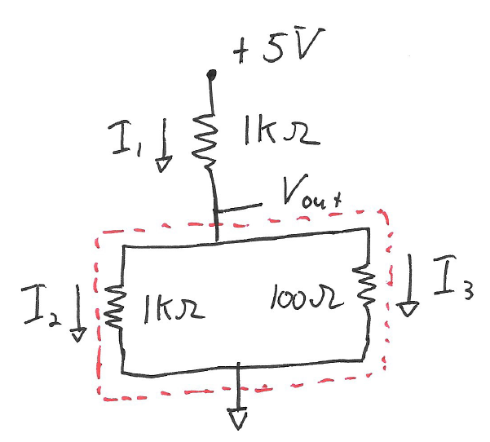
- Vout (theory) =
- Vout(measured) =
- I₁ (calculated)=
- I₂ (calculated)=
- I₂ (calculated)=

- For the circuit in 4), we redraw with an equivalent circuit as in 3). What is the value of R_{eq} that replaces these resistors in parallel (i.e., those in the red, dashed box)?

- Redo problem 4 replacing the 100 ohm resistor with 100 K.

- Vout (theory) =
- Vout(measured) =
- I₁ (calculated)=
- I₂ (calculated)=
- I₂ (calculated)=
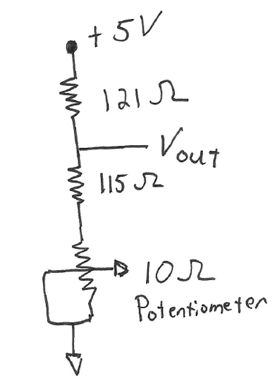
- Build the following circuit using a 10 ohm potentiometer (variable resistor). Note that the potentiometer has three terminals and we connecting 2 to 3.

Schematic: https://www.electronics-tutorials.ws/resistor/potentiometer.html

The potentiometer resistance from pin 1 to 3 is 10 Ohms.
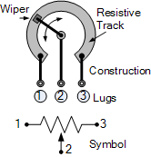
What are the minimum and maximum values for R_{1 to 2}?

Schematic: https://www.electronics-tutorials.ws/resistor/potentiometer.html

What is the maximum and mininum value of V_{out}?
- V_{out} (theory) maximum = ____________ minimum = _______________________
- V_{out} (measured) maximum = ____________ minimum = _______________________

