PSet 3: Resistors in parallel

How does the Analog Discovery influence your circuit?

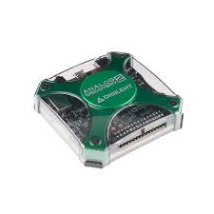
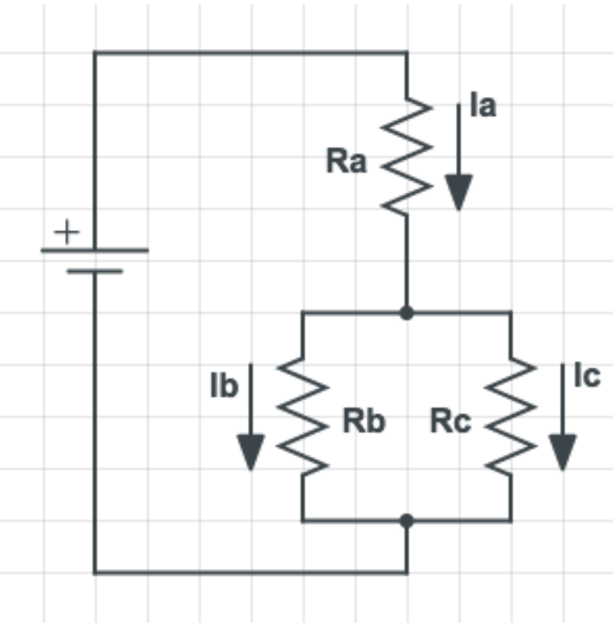
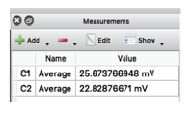
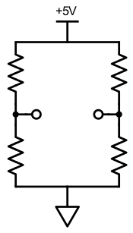
Goal: Use a breadboard and resistors to measure how analyzing a circuit can change how it works, and use that information to make wise choices about resistor values.

Build & test circuits

Compare to calculations

Test AD internal impedance

Think through the self-assessment questions

Submit your Pset

Meet the Wheatstone bridge
Learning objectives
- Use your power supply and breadboard to construct resistor circuits;
- Contrast theoretical voltages with measured values;
- Calculate the output of a voltage divider;
- Measure the effect of the Analog Discovery’s internal impedance;
- Introduce yourself to the voltage divider’s cousin - the wheatstone bridge;
- Self-assess your comprehension and comfort with the material

Visual Summary

- Build circuits and compare to calculations
Build and test the following three voltage dividers. Notice that the measurement point (V_{out}) is now implied, rather than drawn explicitly. What would you calculate V_{out} to be for each of these circuits? Be sure to measure your true value for V_{in} (don’t just estimate as 5V) and include at least 3 significant digits in your measurements.
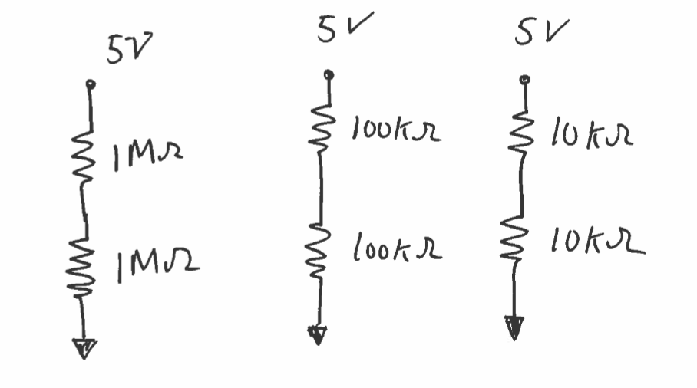

Circuit | Measured V_{out} | Calculated V_{out}
1M resistor
100K resistor
10 K resistor

- Test the Analog Discovery Impedance
Notice that while you might expect that all circuits would have the same voltage between the two resistors, this is not what you measure. The reason for the departure is that the measurement device has an internal resistance (“input impedance”-- see section 2.4 of the course book for an explanation), so that it acts as if you’ve added a resistor in parallel to the resistor that it is measuring.

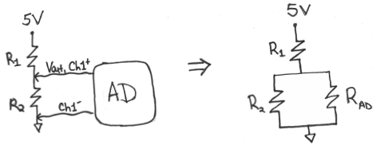
From the three measurements infer the approximate value of the Analog Discovery’s input impedance/resistance. Defer to your calculations using data from the higher resistor values if you get widely ranging results. Include your calculation and measurements.
What value of input impedance for the Analog Discovery best explains your data?

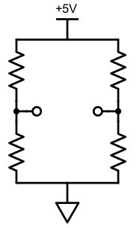
Value of Analog Discovery input impedance (resistance):__________________________________

100 Ω
R4
ΔV
200 Ω
200 Ω

Meet the Wheatstone bridge
The Wheatstone bridge is an all-star measurement circuit. It has been in use since 1843, and is still widely used today for applications as advanced as the Large Hadron Collider! We will be using it in our next lab. In the schematic to the right, what value of R4 would result in a ΔV = 0 Volts? Think through where you would put your test leads to measure this voltage.

Value of R4:__________________________________

Self-Assessment of Understanding
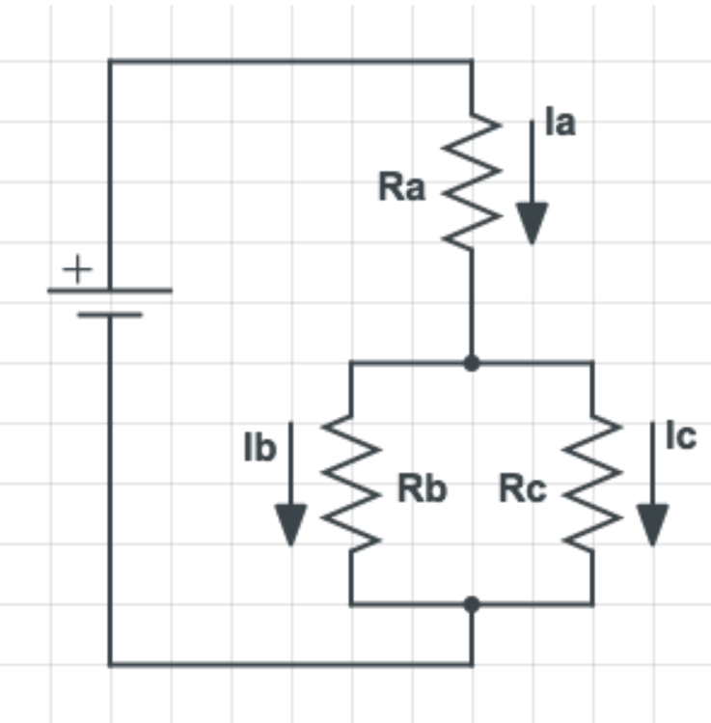
Before we move on to more complex circuits, we want you to self-check your understanding about circuits with resistors. Developing an intuition for how these pieces interact with each other will be important as you are designing and debugging future circuits. All of the questions below are conceptual. You may want to memorize or keep the following ideas handy (perhaps by making a formula sheet): Ohm’s law, Kirchhoff ’s current law, and the equivalent resistance for resistors in series and parallel.

- For the given circuit, which one of the following statements is true?
- I_{b} = I_{c}
- I_{a} = I_{b} + I_{c}
- I_{a} + I_{b} +I_{c} = 0
- Cannot determine without knowing resistor values

- If you have two resistors (R_{a} and R_{b}) in series, what will equivalent resistance (R_{eq}) typically be relative to R_{a} + R_{b}?
- Higher (R_{eq} > R_{a} + R_{b} )
- Lower (R_{eq} < R_{a} + R_{b} )
- Equal (R_{eq} = R_{a} + R_{b} )

- If you have two resistors (R_{a} and R_{b}) in parallel, what will equivalent resistance (R_{eq}) typically be relative to R_{a} + R_{b}?
- Higher (R_{eq} > R_{a} + R_{b} )
- Lower (R_{eq} < R_{a} + R_{b} )
- Equal (R_{eq} = R_{a} + R_{b} )

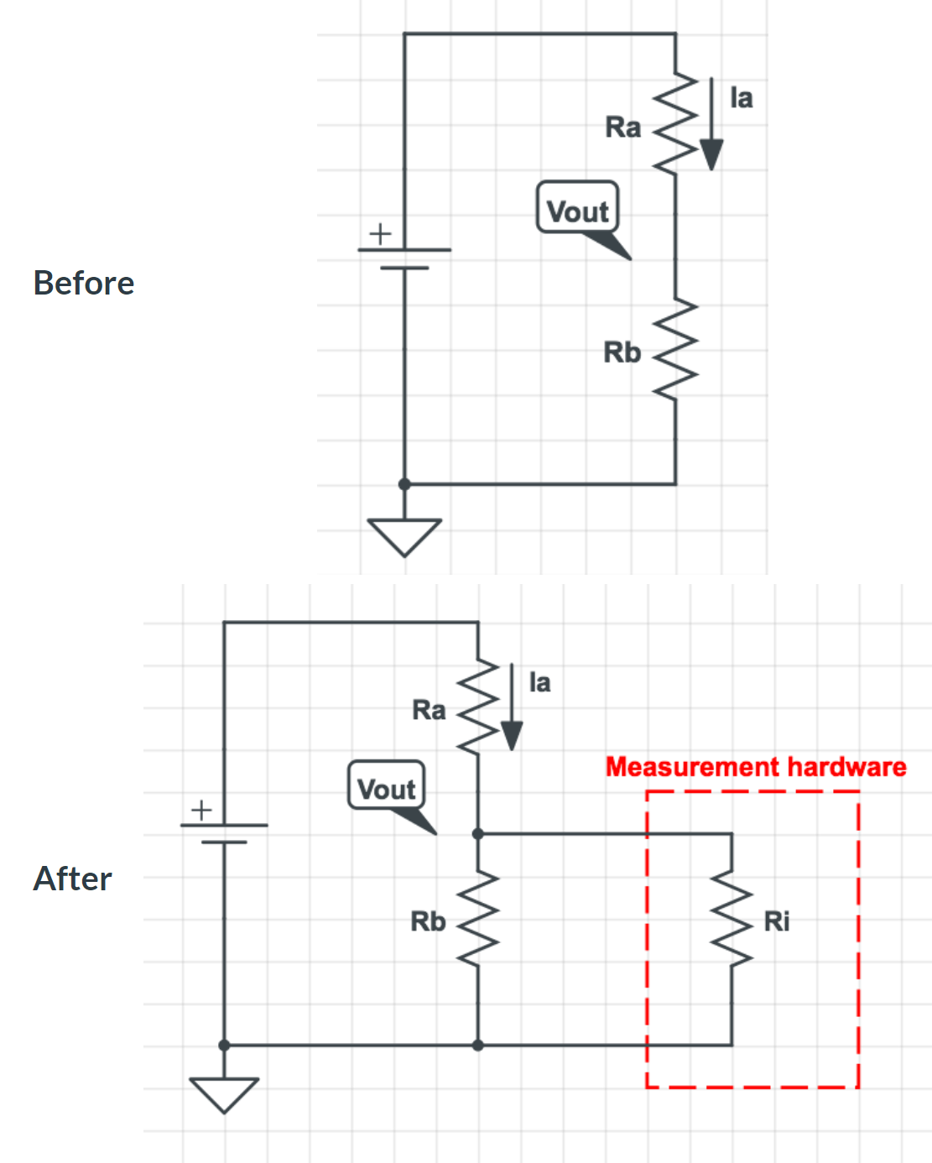
- Imagine that you built the top "Before" circuit, and then attached a measurement device with input impedance Ri as shown in "After". What can you say about the current I_{a} and the voltage V_{out} relative to ground?
- V_{out} decreases, I_{a} decreases
- V_{out} increases, I_{a} increases
- V_{out} increases, I_{a} decreases
- V_{out} decreases, I_{a} increases
- Cannot determine without knowing resistor values

Solutions are here!

