Lab 6: Blood pressure
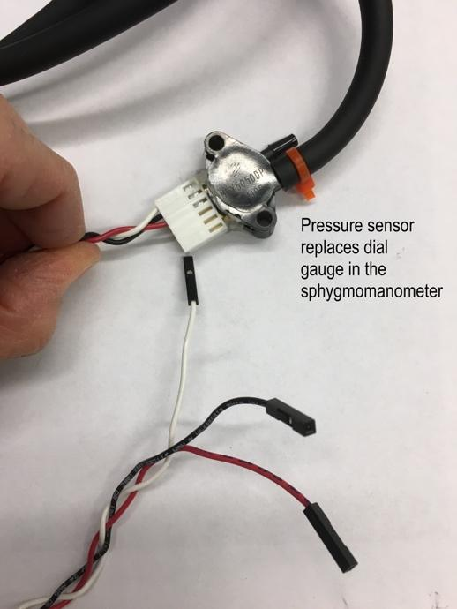
Basic manual sphygmomanometer
https://www.medicalsupplydepot.com/Diagnostic-Products-1/Blood-Pressure-Monitors-2/Aneroid-Manual-BP-Sphygmomanometer-Kit.html

Replace dial gauge with a
Freescale Semiconductor Pressure Sensor MPX5050GP (https://www.nxp.com/docs/en/data-sheet/MPX5050.pdf)

https://www.digikey.com/product-detail/en/nxp-usa-inc/MPX5050DP/MPX5050DP-ND/464057

Wiring:
Pin 1: Vout (White in image)
Pin 2: Ground (Black in image)
Pin 3: Vcc, 5 volts (Red in image)

