Lab 3: Measuring mass using a strain gauge
Goal: Measure mass using a special voltage divider, an amplifier and a strain gauge.
Learning objectives
- Combine voltage dividers in parallel (“Wheatstone bridge”) to measure a small ΔV;
- Use a strain gauge to sense small changes in length caused by a force;
- Operate a potentiometer to balance a Wheatstone bridge;
- Use an instrumentation amplifier and explain its effect;
- Construct a calibration curve for your scale;
- Determine the sensitivity of your scale;

Visual Summary
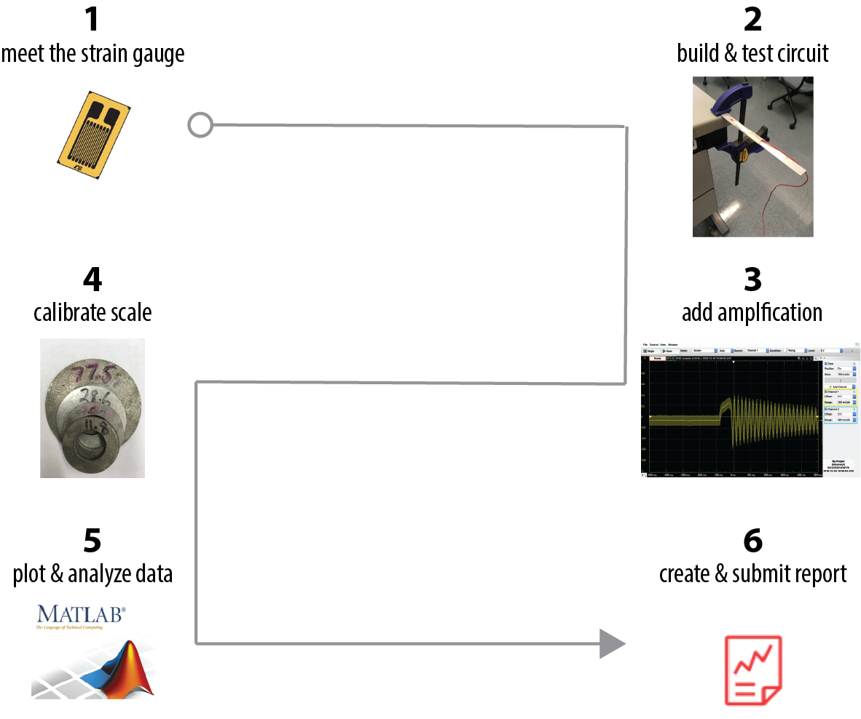
In this lab, you will make measurements of mechanical strain in small aluminum beams as you bend them. We will also work with our first integrated circuit component on the breadboard, the instrumentation amplifier.
- Meet the strain gauge
ΔL
The strain gauge is nothing more than a resistor whose value changes when it is elongated or compressed. When elongated, the small wires which make up the strain gauge get longer and thinner and the resistance goes up. When compressed the wires get shorter and fatter and the resistance goes down. When a strain gauge is stretched, its resistance changes according to the following formula
$\frac{∆R}{R}=G_{F}\frac{∆L}{L}$
where $G_{F}$ is the gauge factor (it is 2.1 for our sensors), $R$ is the starting resistance of the strain gauge (120 Ω in our case), $∆R$ is the change in resistance, $∆L$ is the local change in the length of the material, and L is the initial un-stretched length. The ratio of lengths is known as the mechanical strain. Since strain is usually quite small, the change in resistance is also quite small. Strain is a normalized measure of how much the material deforms.
- Build & test circuit
The classic circuit for measuring resistance change is the Wheatstone bridge, shown below in Figure 1 (left). At first glance, this may look like a strange circuit, but it is simply two voltage dividers wired so they are in parallel with one another.
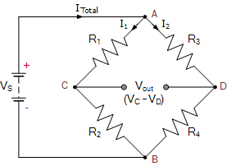
Circle each of the two voltage dividers. (hint:V_{s} = V_{in})
What do you expect V_{out} to be if R₁=R₂=R₃=R₄?
Figure 1. Wheatstone bridge. Image source: https://www.electronics-tutorials.ws/blog/wheatstone-bridge.html
We’ve redrawn the Wheatstone bridge in Figure 2, below, with our strain gauge as one of the resistors. In our case, the nominal resistance of the strain gauge is 120Ω when no load is applied. If all the resistances are exactly 120.0 Ω, the bridge is balanced.
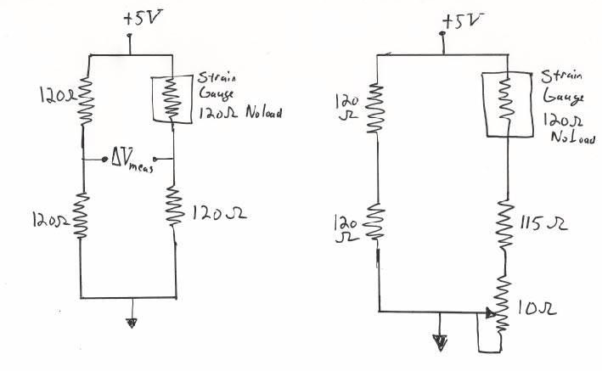
If all components had the exact resistances as shown in Figure 2, at the midpoint between the resistors on the left and right branch, the voltage would be 2.5V relative to ground on each side. Thus, when you measure the difference, $ΔV_{meas}$, you would see 0V at no mechanical load on the strain gauge. If the resistance of the strain sensor then changes, you would measure a slight voltage difference across $ΔV_{meas}$ which is related to the resistance change of the strain gauge.
Figure 2: Classic Wheatstone bridge for sensing small changes in resistance. On the left is a classic bridge with perfectly matched resistors. On the right, we use a potentiometer to balance the bridge such that the measured voltage is 0 when the strain gauge is unloaded. This accounts for the fact that the resistors are not precise.
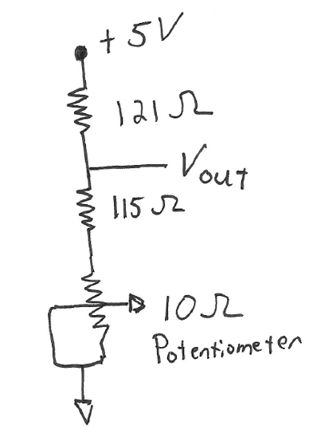
Unfortunately, real resistors come with finite tolerances (e.g., ±1% for most of the resistors we use). Consequently, we typically add a variable resistor (a trim potentiometer or “pot”) to the bridge, as shown in Figure 2 (right), in order to balance it manually.
You may recognize this potentiometer configuration from Class 4.
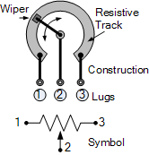

Schematic: https://www.electronics-tutorials.ws/resistor/potentiometer.html

We will balance the bridge by adjusting the potentiometer and measuring ΔV_{meas}.
How will we know that the bridge is balanced?

We will start by building the basic circuit shown in Figure 3. Just to make your life confusing there are two types of strain gauges – the type doesn’t matter but the connection is slightly different for the two types.
Sorry. We bought different parts on accident and didn’t notice until time was too short to reorder.
Some strain gauges we have are 3-wire measurements to reduce error due to resistance of the wire leads.
The 2-wire gauges are simple resistors

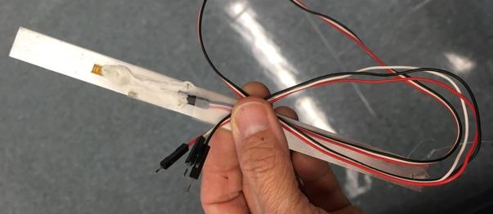
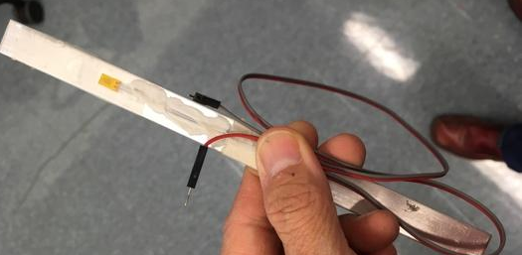

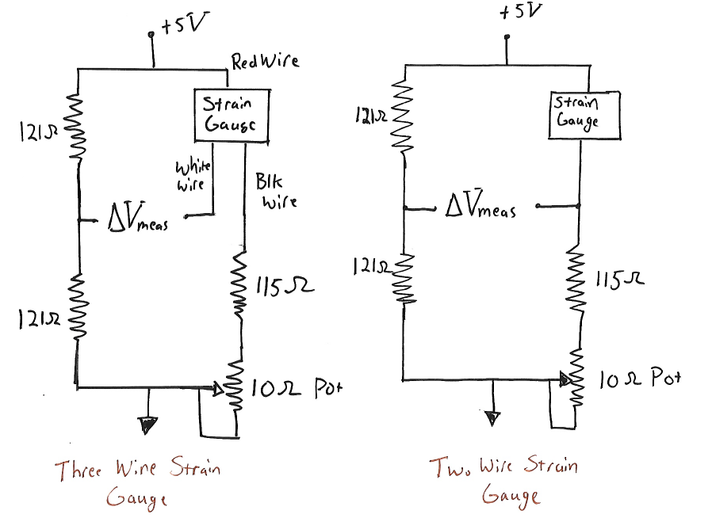

Figure 3. The first circuit you should build to measure strain via the change in resistance.
The nominal resistor values are not always those we would like to use (e.g., the closest standard value for 1% resistors to 120Ω is 121Ω). We use resistors that are ±1% of their nominal value.
It turns out that if we substitute any two resistors of equal resistance* in the left leg of the Wheatstone bridge (i.e., one of the voltage dividers), the circuit will still function the same.
Why?
*The resistors must also have a tolerance of ±1%.

Before wiring the strain gauges, make sure that it has a resistance of ~120Ω.
For the 3-wire gauges, measure the resistance from the red to each of the other leads.
If is the R<<120Ω or R>>120Ω, the strain gauge is probably broken.
If so, please inform an instructor & get a different assembly.
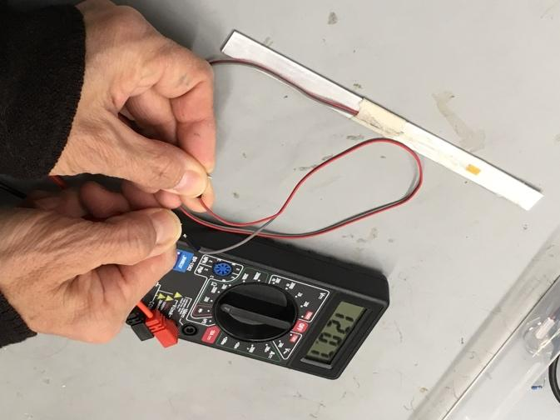
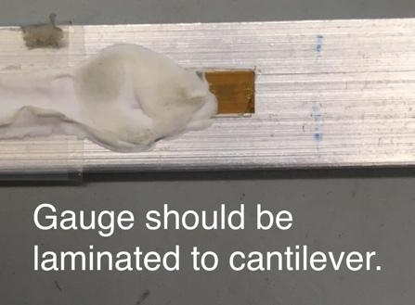
Check your strain gauge for mechanical integrity.
If the gauge is delaminated, please inform an instructor & get a different assembly.

Connect the Analog Discovery
Use either Ch1 or Ch2 to measure the ΔV across the two mid-points of each voltage divider (Fig 3, ΔV_{measure}) .

Within Wavegen, +Scope. Set the display Mode: Screen
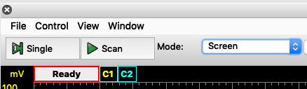

The ΔV should be ~0. Zoom in the y-axis scale on the Scope to 50 mV per division. Adjust the potentiometer up and down. You should be able to control the voltage difference across the bridge to be around ± 50 mV.
If you are unable to make the voltage change by twisting the potentiometer – something is wrong. If you are unable to push the voltage difference both above and below zero – the system won’t work.
TROUBLESHOOTING TIPS
System not working as expected? What exactly is happening?
e.g: You turn the potentiometer across its full range and it looks like ΔV~0.
These are your assumptions so far. You can test any of them.

Once you are sure the circuit is working, balance the bridge and set the measured voltage to zero as best you can. It is not crucial that it is perfectly zero, in fact it is likely to jump a little when you take the screwdriver off the potentiometer.
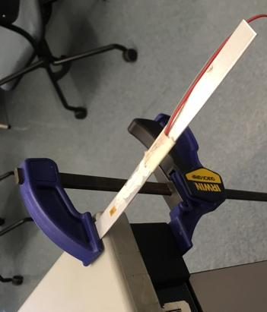
Test with the cantilever/strain gauge
Zoom your scope axis to be around 10 mV/division.
Clamp the beam to cantilever off your desk where the strain gauge is facing up and is just over the edge of the desk.
Push the beam downward, gently; you should notice changes on the order of a few mV.

If you do not see changes ~mV, do not push harder.
The aluminum beam will easily deform.

- Add amplification
The ΔV_{measured} from the Wheatstone bridge resulting from a change in the strain gauge's resistance is ~mV; we can amplify it for a better measurement. To perform the amplification, we will use the instrumentation amplifier “AD623”.
We will discuss in lab how it works. In short, we will use this chip as a “black box” that takes a voltage difference and amplifies it by a large number on your breadboard.
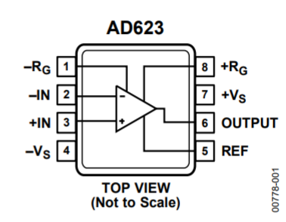
The top of AD623 is marked with a divet.

Build the circuit shown in Figure 4 (with slight modification if you are doing the two-wire measurement). Note the schematic uses a capacitor with a value of 100 picofarads (pF). We have not discussed capacitors yet (next week). The capacitor helps remove radio frequency noise, but does not influence the basic operation of the circuit. Once you have the circuit built, you will need to hook up the scope again. Plug channel 1 positive input into the output of the instrumentation amplifier and the negative input for channel 1 into the 2.5 V reference on your breadboard.
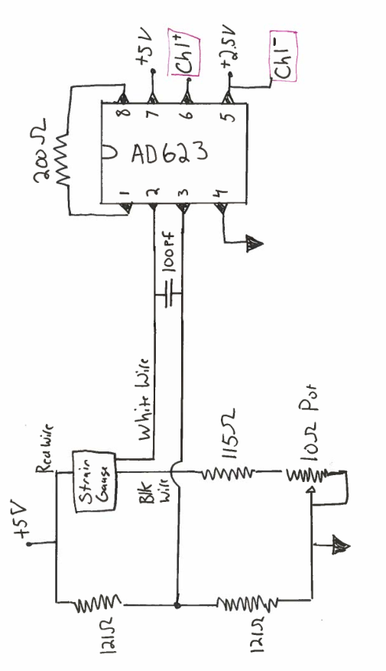
Figure 4: Final strain gauge circuit.
Rebalance the bridge to zero (or close as you can get).

The output of the instrumentation amplifier is designed to be,
$V_{out}=V_{ref}+G\left(V_{+}-V_{-}\right)$
In the above expression V_{out} is the voltage on pin 6, V₊ is the voltage on pin 3, V₋ is the voltage on pin 2, and V_{ref} is the voltage on pin 5. Note that V_{ref} is set to 2.5V in our experiment. When we measure V_{out} relative to V_{ref}, we can measure the change in voltage caused by the beam being bent up or down.
What is the expected Vout when the beam is at rest (i.e., no strain on the gauge)?

The value of G, the gain, is set by the expression:
$G=1+ \frac{100,000 Ω}{R_{G}}$
The gain is selected by the user (i.e. you) be selecting the value of the resistor connecting pins 1 and 8. We use a 200 Ohm resistor, therefore G=501 for our circuit. Note that the above equation is determined by the internal design of the chip and is not some fundamental law of physics (though later in the course we could understand where the design equation comes from!).
Once the systems is balanced, try pushing down slightly on the end of the beam with your finger and you should see a nice voltage change. You will need to adjust the scope scale back to something like 1V/division. Push the beam up and it should change in the other direction. Flick it and you should see damped oscillations. When you unload the beam, the signal should return to zero. Note that it is probably impossible to perfectly balance things with the potentiometer. This is fine. It is really only the change that is important anyway.
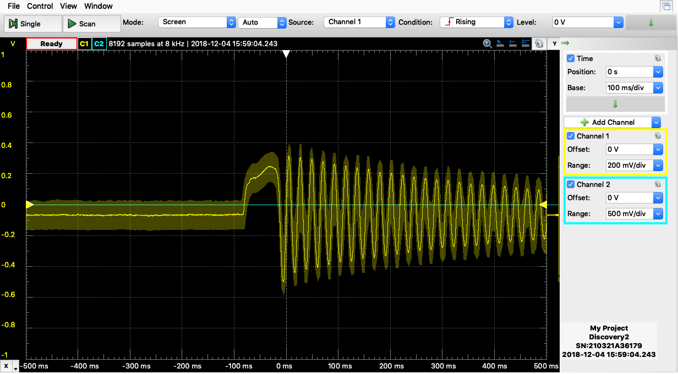

- Calibrate the scale
Once you are happy that things seem to work, take some fishing line and tie a string to the end of the beam with the attached strain gauge. Add a paper clip “hook” to the end of the string.
Note that you may need to balance the bridge by adjusting the potentiometer so that you have close to zero volts with no load.
Create a calibration curve using a series of washers; each washer is labeled with its mass in grams. You might see some oscillations as the system comes to rest. If the washer is swinging, the signal will show an oscillation at the frequency of the swing. If this is the behavior you observe, then everything is working great.

Do not add more than 300 grams.
This final plot with your best fit calibration curve should be part of your lab report. This calibration line becomes your scale.
ΔV is linear with ΔR_{gauge}; ΔR_{gauge} is linear with strain; Strain of the gauge is linear with mass.
How do you expect the ΔV to vary with mass?
Is the shape of your calibration curve as you expect?

Take one of the large washers with an “unknown” mass and load the beam while monitoring the voltage at the output of the instrumentation amplifier. Measure the voltage and you can now compute the mass from the calibration.
- Plot and analyze
In your lab report, discuss your scale sensitivity (A measure of sensitivity is $\frac{dV_{output}}{d{mass}_{input}}$. )
For your circuit, a 20 mV change in the output voltage seems to be easily discernable. For a 20 mV change,
- What is the associated change in electrical resistance of the strain gauge? You will need to do a little analysis here.
- What is the mass that was applied to the scale to get this change of 20 mV on the output voltage?
- Create and submit report

