PSet 4: Capacitors and RC circuits
In this week’s lab, we will start to use capacitors and learn about their wonders.
Goal: To observe how capacitors respond to direct current (DC) voltage inputs and an alternating current (AC) voltage square wave input.
Learning objectives
- Recognize that a capacitor stores charge;
- Graph the voltage change across and current through a capacitor as it charges;
- Use Wavegen to produce a square-wave AC signal of a specific frequency and amplitude;
- Compare the measured V(t) with the theoretical capacitor response;
- Calculate the approximate time constant, τ, of an RC circuit;
- Plot the voltage drop across a capacitor with changes in the square-wave input frequency

Visual Summary
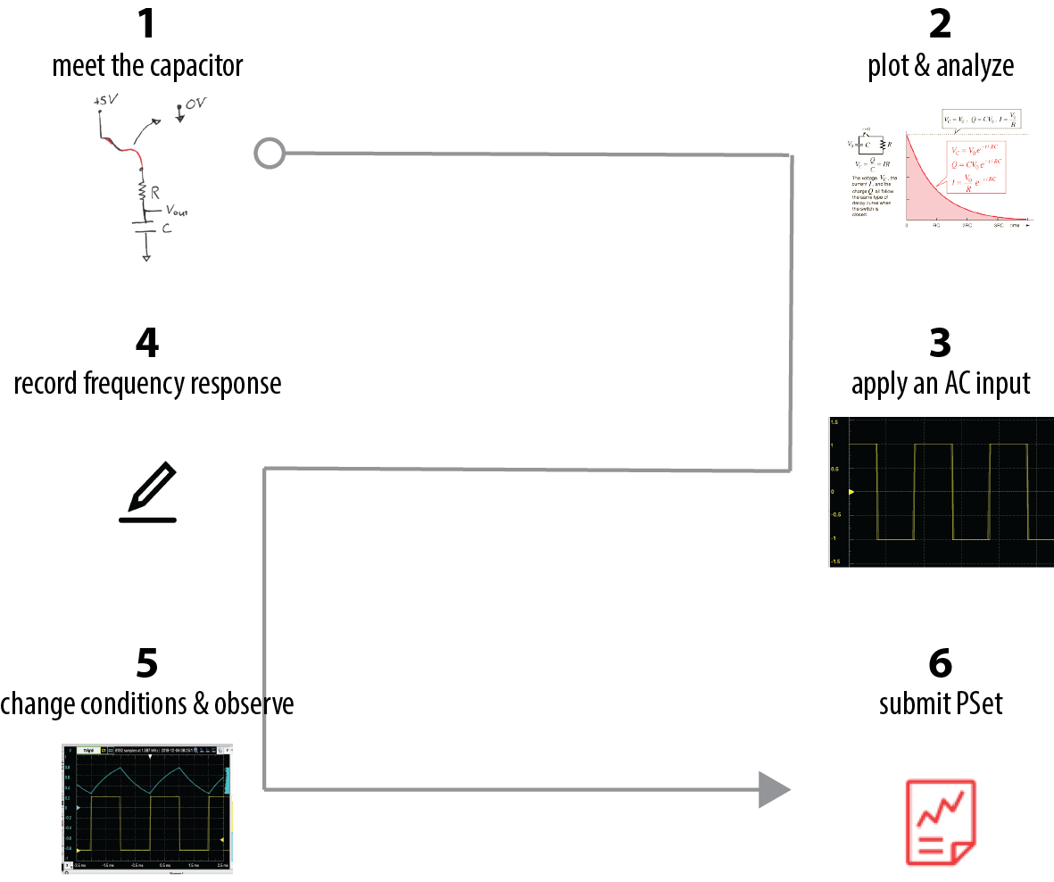
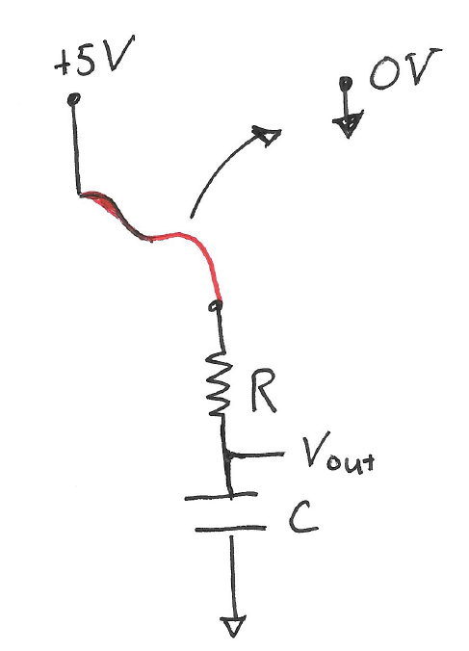
- Meet the capacitor

Build the circuit below, using a wire
This squiggly line is a long-ish loose wire that you’ll use to switch to 0 Volts.

(100 KΩ)
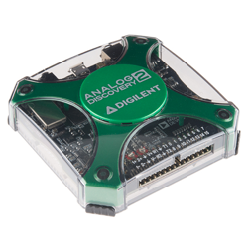
(10 μF)
Make sure the AD shares the same Ground as your circuit & computer.

Set up the AD so that it uses Chanel 1 to measure the ΔV across the capacitor.
Where should the Ch1+ and Ch1- probes connect?

Add , ►Run. Use the tips in the graph below to find your signal.
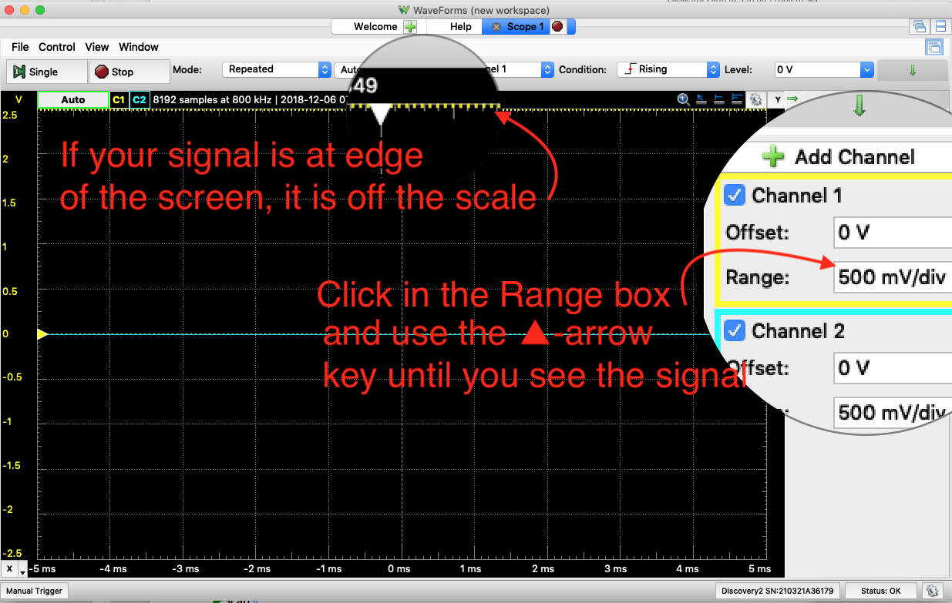

Prepare to monitor what happens over time when you switch from 5V to 0V input:
Set Mode: Screen, Change the Time>Base: 1 s/div, Time>Position: 4s
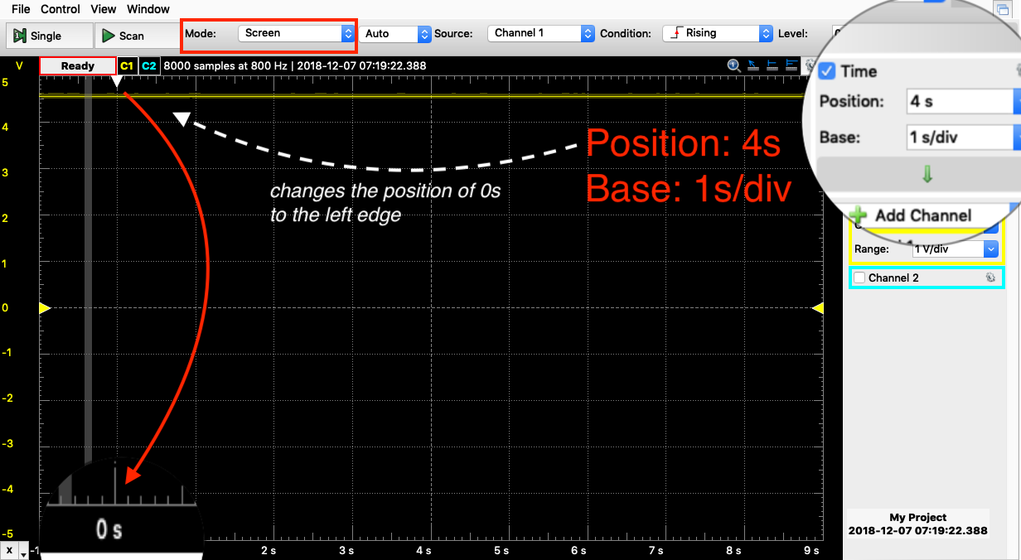
By hand, quickly move the wire at +5V to ground. Watch the voltage across the capacitor change with time. We call this behavior “discharging.” Record your observations on the PSet worksheet (page 8)
What is physically happening during the dis- charging?

Now, you will record the change in ΔV_{cap} during charging. If your capacitor has fully discharged, Ch1+ should indicate V_{out}=0.
Disconnect the input wire from Ground.
When the cursor scope gets to 0 s, plug the V_{in} wire to the +5 V rail of your breadboard. Stop it when it gets to 9 s and save this plot.
- Plot & analyze
The plot of V(t) is theorized to adhere to $V\left(t\right)=V\left(∞\right)∙ {(1- e}^{-\frac{t}{τ}})$(p. 35, text*). In this section, you will use the Scope tools to determine the value of $V\left(∞\right)$ and τ. Then you’ll plot the measured V(t) with the analytical (i.e., theoretical) V(t).
*in the text, V(∞)=1 and τ=1.
How can you tell if t(time) is large enough that V(t)→V(∞)?
$V\left(t\right)=V\left(∞\right).$ We don’t have t=∞, but we have a large enough t that V_{out} ≈ V(∞)

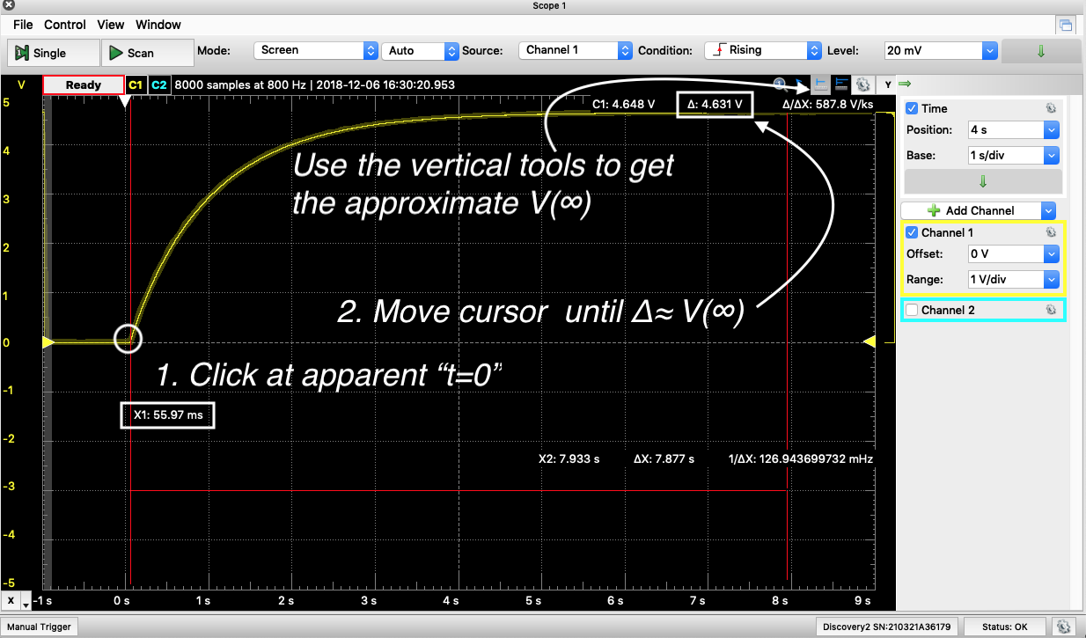
Now we need to use the same tool to find the value of τ. In this case, the t=0 starts at X1~59 ms, V(∞)≈4.63 V. We can determine τ from $V\left(τ\right)=4.63V∙(1-e^{\frac{-t}{τ}})$.
When t=τ, what will be V_{out} for your circuit?

Use the vertical tool to determine τ from your data.
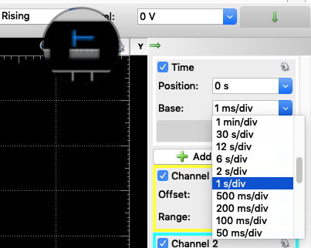
Left click on the tool,
With the cursor, point to and left click (and release) on the apparent V(t=0)=0 position. This is the point at which V_{in}=+5V.
Move the cursor to the right until the Channel 1+ value (C1), Δ = V(t=τ). At this point, ΔX = τ.

Record your measured values of V(∞) and τ on the PSet worksheet (p. 8).
Plot and compare the measured and theoretical V(t) for the charging capacitor.
For a quick guide on using MatLab for these plots, see isim.olin.edu, Class 6.
Your theoretical charging curve is likely to fit well to the experimental data.
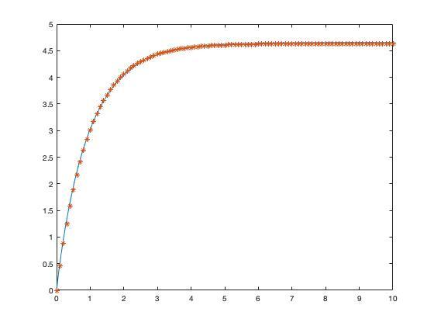
Here is a tiny, unreadable graph to illustrate that the theory “*”, fits to the blue line of measured data.
As a reminder, here is the circuit before you began charging the capacitor:
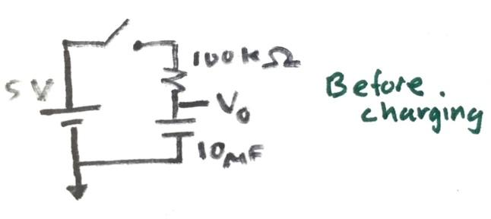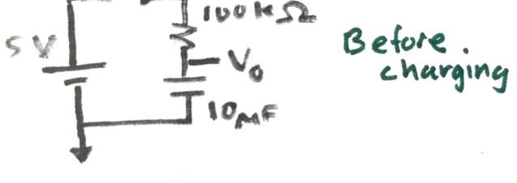

I
From our text, we know that the equation for the current through the capacitor is $I_{cap}\left(t\right)=C∙\frac{dV}{dt}$, where $V$ is the voltage drop across the capacitor. In our case, $V=V_{out}-0V=V_{o}$.
As always, the units of measure are important. 1 Amp = 1 Farad Volt/second
What is the equation for current through the resistor, I_{resistor}?

On the same graph, plot the currents through the resistor and capacitor. Use $V_{measured}(t)$ for the resistor and $V_{theory}(t)$ for the capacitor.

Please return the 10 μF capacitors to their proper bins.
- Apply an AC input
Now we are going to see how capacitors respond to AC inputs. Build the circuit below and connect the AD.
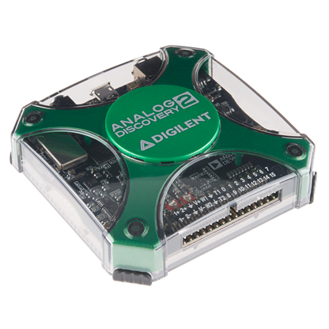
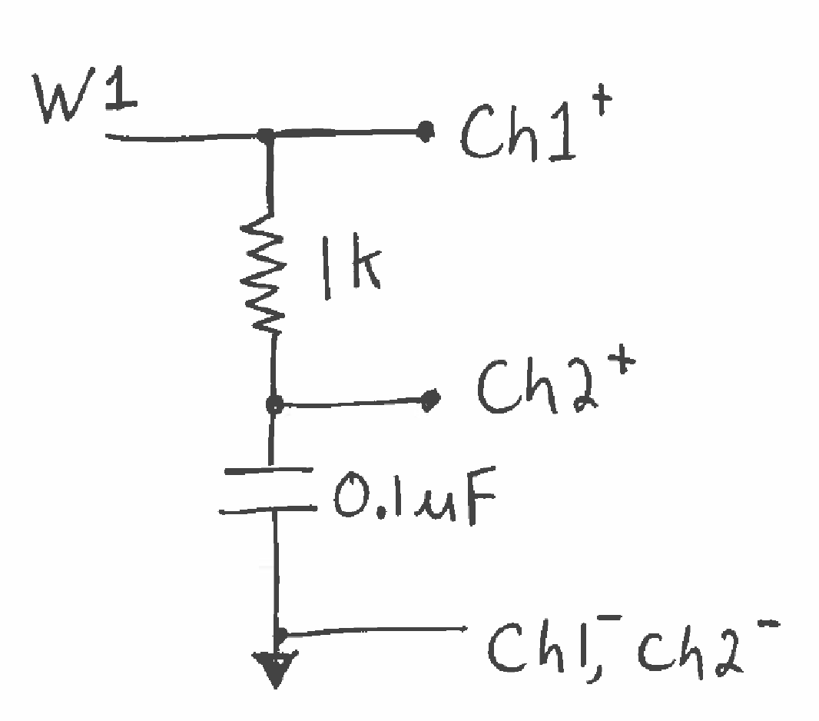
Use Wavegen 1 as the V_input
Use Scope Ch1 to monitor V_input;
Use Scope Ch2 to monitor the V dropped across the capacitor.
The Discovery and circuit should share a ground.
Figure 1: Simple RC circuit for part 2 of the lab.
You should have nothing from the Analog Discovery connected to the 5 Volt power rail on your breadboard.
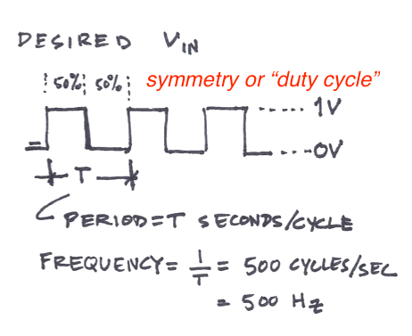
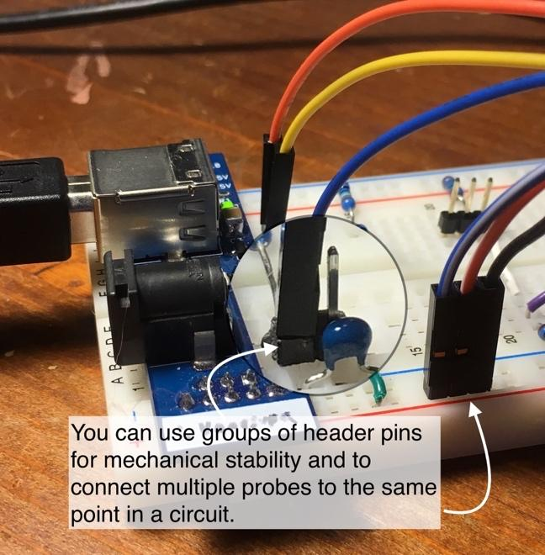

Use
to create the desired V_{in} and then ►Run

Setup ►Run. You should see the voltage response of several cycles. If not, let’s troubleshoot:

If the signal is scrolling by on the screen, you can fix the data to the t=0 point by specifying

Trigger conditions: What data source? What condition of the data? What voltage level of the condition?
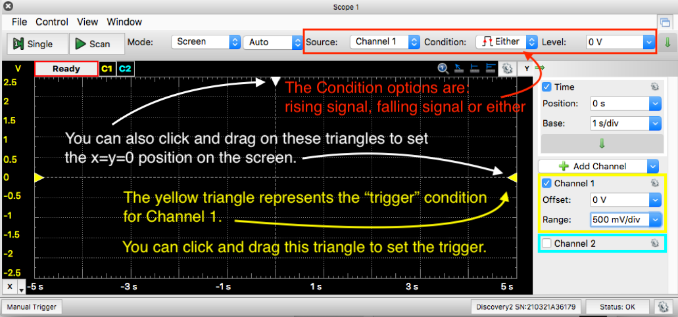
Are the Voltage signals off screen?

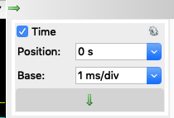
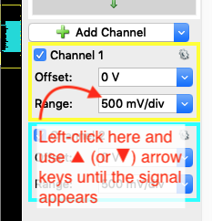
Arrow-stepping
Let’s call this
This process will help you in trouble-shooting

Can you see the waveform?
If not, you can arrow-step to stretch/compress the Time Base:

Comment in the worksheet on the ways the capacitor response to frequency changes is similar to or different from the response you got from Part I.
- Record the frequency response
You’ll need to work with both Scope and Wavegen:
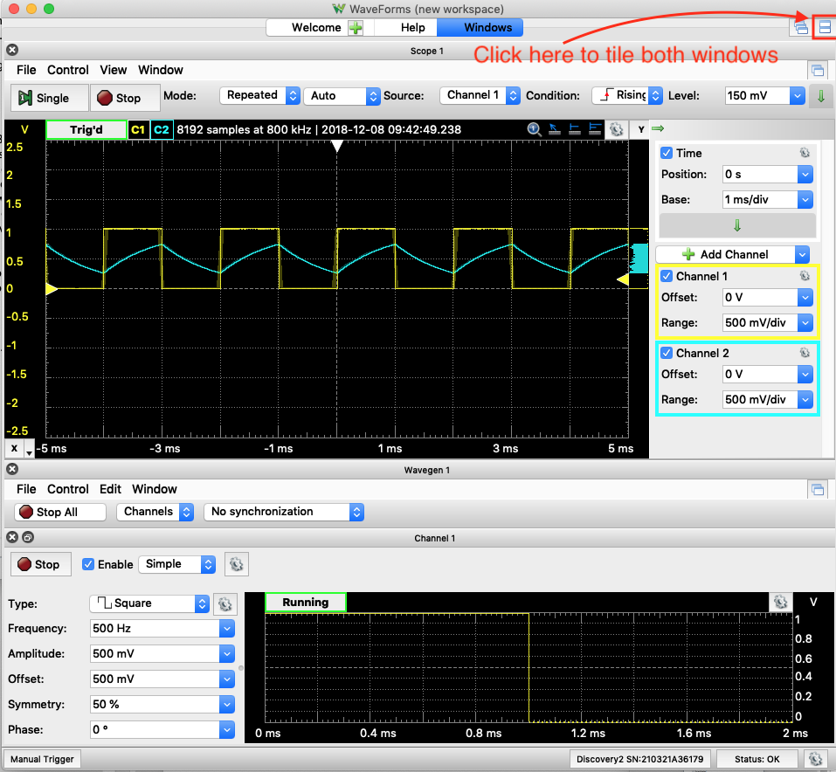
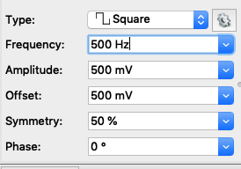
In the Wavegen, left-click in the Frequency: box.
Use ▲ arrow key to step up to 1.5 kHz (“Arrow-stepping”) and notice what happens.
Now, try adjusting the frequency up and down using “Arrow-stepping” to observe what happens to the output signal as frequency increases.
The behavior you observe should be the similar as in Figure 3.9 of the book.

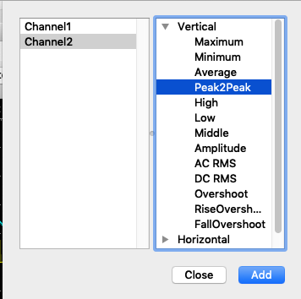
In , View>Measurements, Add Defined Measurement, Channel 2>Vertical> Peak2Peak.
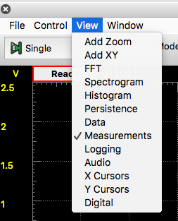

Now adjust the V_in frequency using “Arrow-stepping”, from 100 Hz to 200 kHz. Notice and record the voltage drop over the capacitor in the PSet worksheet (Column 1, table, p. 11).
- Change the conditions & observe
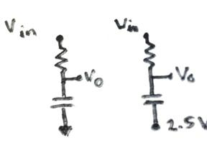
Now change the input signal to be a square wave with 1 V amplitude, centered at 0V (PSet Worksheet table, Column 2, p. 11). Record the voltage drop over the capacitor at the different frequencies.
Now change the reference for the capacitor from Ground to 2.5 V.
Repeat the sweep of frequencies and record the values in the PSet Worksheet table, Column 3.

- Submit PSet
Deliverables:
For this assignment, you turn in the worksheet and the plots you were requested to make. Create plots with clear axis labels with units. The plot should be well labeled. This is not a lab report, so just the plots.

PSet 3 Worksheet
- Meet the capacitor
Sketch what you observed of V_{out}(t) upon moving the V_{in} = +5V➝ 0V. In this rough sketch, label the axes, and the V(t=0s) and V(t=9s) second values.

The theoretical discharging curve for an RC circuit is $V\left(t\right)=V(0)∙e^{-\frac{t}{RC}}$. How did your observed V(t) deviate from this idealized exponential decay and why?

- Plot and Analyze
V(∞)_{measured} = _______________ Volts approximate τ_{measured} = ___________sec
Compute RC for your circuit, RC = ______________sec.
Theoretically, RC=τ. Compare the RC for your circuit to the experimental τ

Include the following plots for the charging capacitor:
- V(t) for the charging capacitor with V(t)_{theory},
- I(t) for the resistor with I(t) for the capacitor
Comment on plot 2:

- Apply an AC Signal
Comment in the worksheet on the ways this response is similar to or different from the response you got from Part I. Sketching and labeling a single cycle can help explain.

- Change frequency & 5. Response
This RC circuit is considered a filter for the input signal. Would you call it a high-(frequency)pass or a low-(frequency)pass filter?

What trends do you notice in the ΔV of the capacitor as the frequency is increased?

How does changing V_{in} affect the trend of ΔV(freq)?

How does the reference voltage (0V or 2.5V) affect ?

How the the ?
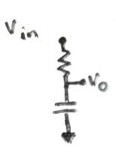

Conditions: | V_{in}=  0 – 1 V | V_{in}=  -1 to 1V | V_{in} =  -1 to 1V
V_{in} freq  (Hz) | ΔV over capacitor  (volts)
100
200
500
1 k
2 k
5 k
10 k
20 k
50 k
100 k
200 k

