PSet 5: RC circuits as signal filters—FFTs and the Bode plot
See attached worksheet, pp. 11-13

Goal: Build and characterize the filtering behavior of two different filter circuits at a range of frequencies.

Learning objectives
- Assess the frequency content of an input signal using the FFT spectrum;
- Create and Interpret a Bode plot for a filter circuit;
- Convert frequency (f, cycles/s or Hz) to angular frequency (ω, 1/s or, equivalently, radians/s);
- Verify that V_{out}/V_{in} is -3dB at the cutoff frequency;
- Compute the cutoff frequency of an RC circuit in Hz.

Why would we want to filter signals?
Imagine that you were given a can of mixed red, blue and yellow paint, but you wanted to take out the yellow paint. In the same way, raw sensor signals contain voltage signals that we want and a whole lot more! Filters help us to get rid of parts of the raw signal. For example, let’s say you were listening to a music piece performed by a piccolo (high pitch, or frequency) and a trombone (low pitch), but you only liked the piccolo part. A filter could isolate and block out the trombone part. To help us, we introduce two tools--the Fast Fourier Transform, or FFT. and the Bode Plot.

The Upside-down and the FFT Concept
Have you ever wondered whether we are living in a multi-dimensional universe with multiple “domains,” that perhaps there is an “upside-down” version of our “right-side” up world? Well, wonder no more, because you have been working across the domains of our multi-verse in this very class!
Sketch of a tight-rope walker and a flea, illustrating the premise of an upside-down universe. Source: Stranger Things,”The Upside-Down,” Hulu.

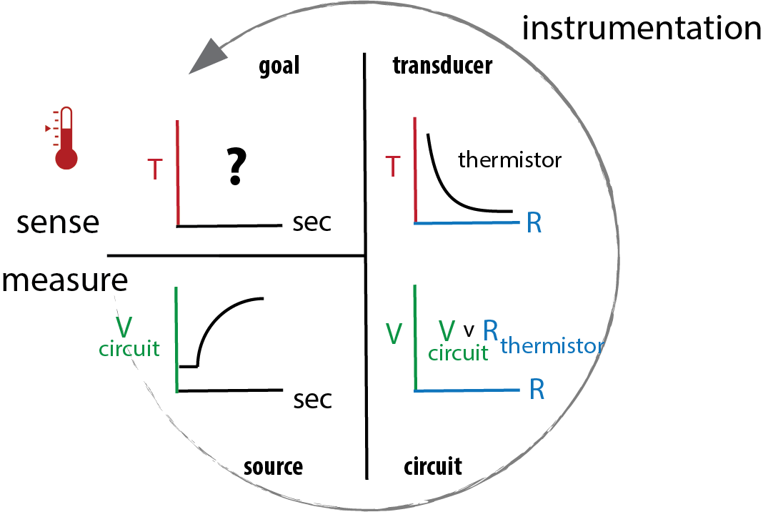
When you measured temperature, you measured it in dimensions of Volts. The electric potential domain (dimension: Volts) is coupled to the thermal domain (dimension: °C) through the instrumentation. Thermal changes show up as changes in voltage and vice versa; you cannot change one without changing the other because it is part of a whole, interconnected universe!!

In the same way, there is an upside-down domain to the signals we measure in time.
If the dimensions in a domain are seconds (s), what would be the dimensions of a domain that is its upside, down?

The FFT is a mathematical tool that separates a time-domain signal into its upside-down version (i.e., 1/s or frequency). It is the SAME signal, but we’re just looking at it from a different domain. It’s the same as looking at temperature through the dimensions of voltage, or looking at a sock, inside-out.
What?

Even though the sock looks totally different when you turn it inside out, we know it’s the same sock. AND, if we were to make changes on the inside of the sock, the outside would also change, and vice versa.

The FFT will help us see the signals through the view of 1/s (frequency) so we can filter out the frequencies that we don’t want and keep the ones that we do.

Alright, let’s see how FFTs work on voltage signals.

Note: The Fast Fourier Transform is a math short-cut version of the Fourier Transform. If you are super-curious, you might want to check out: Introduction to the Fourier Transform by 3Blue1Brown (https://youtu.be/spUNpyF58BY).

Part I: Viewing signals through time and 1/time domains
1. Prepare Channel 1 to measure the Wavegen output (W1).

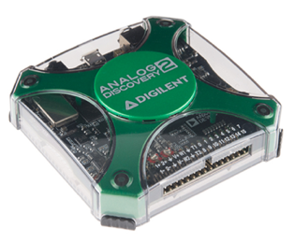
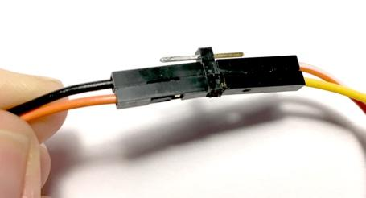
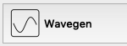
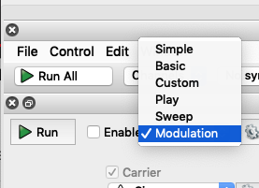
2. Open to generate a signal of 3 sine waves of different periods.
Select “Modulation”
Deselect “FM” and “AM” so that only the signal marked “Carrier” is active.

Note: Think of “Carrier” “FM” and “AM” as three different signals that Wavegen will create. You will control their parameters (Type, Frequency, etc.).

Add 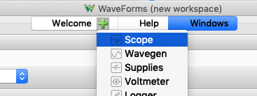 so you can view both Scope and Wavegen, both:

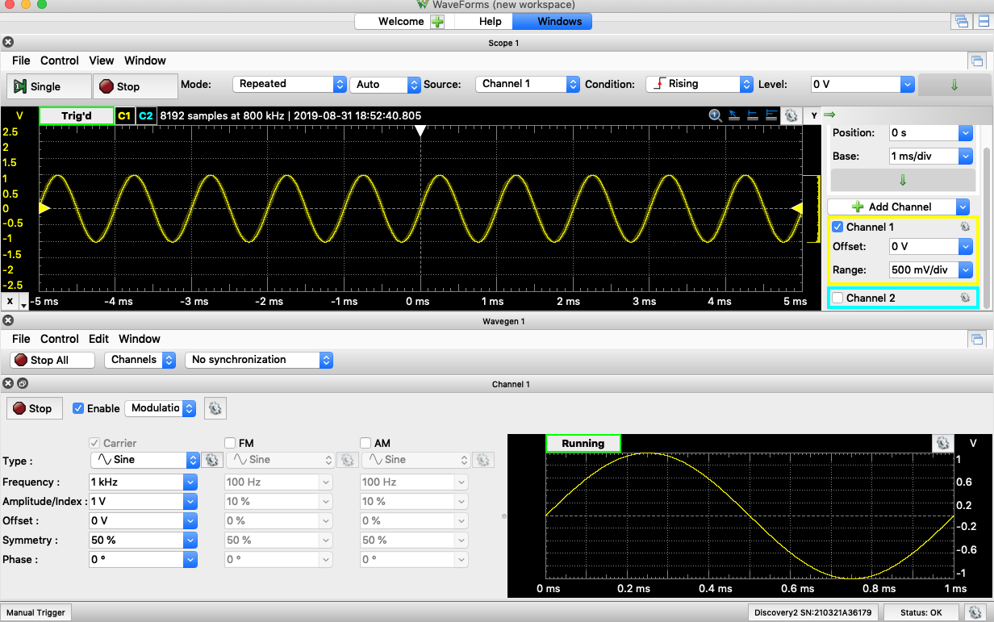

This signal looks like a pure, 1 kHz sine wave, but is it? We will analyze it with the FFT.
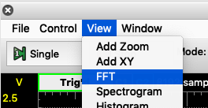
View>FFT

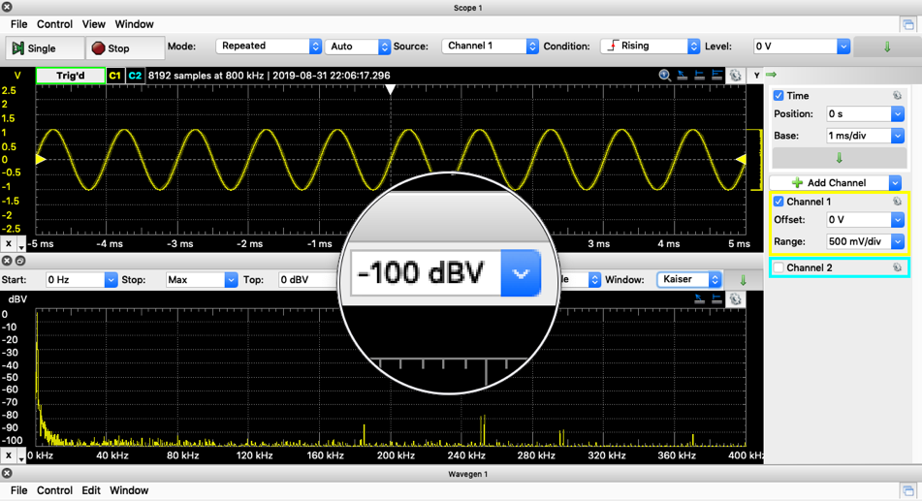
For clarity, deselect Channel 2 and change the Bottom of the FFT scale.

Notice in the 1/s domain, the signal contains the 1kHz signal, but there are other peaks as well. These higher frequency signals are in the composite shown in the time domain, but just not visible.
Record your observations on the worksheet (last page).

3. Change the parameters of “FM” and “AM.” First, REDUCE “Carrier” frequency to 50 Hz

Then, use the following:
FM: Frequency = 20kHz, Amplitude = 100% (of “Carrier) Offset=0%, Symmetry = 50%, Phase = 0
AM: Frequency = 50kHz, Amplitude = 100% (of “Carrier) Offset=0%, Symmetry = 50%, Phase = 0

In the time domain, you will see a signal that sums all 3 input sine waves.

Using the FFT, can you see the three components in the frequency domain?

Zoom in on the FFT output using these settings:

The Exponential dB mean requires a few seconds to compute.

Record your observations on the worksheet (pp. 11-13).

What is the value of the FFT? Record your thought on p. 12.
Part 2. The RC filter and its behavior: The Bode plot
A filter is nothing more than a chain of individual circuit components that work together to eliminate some of the signal. Let’s build one and see how they can help us.

As an example, here is an analyzed signal and I happen to know that my sensor output is at 8 kHz.
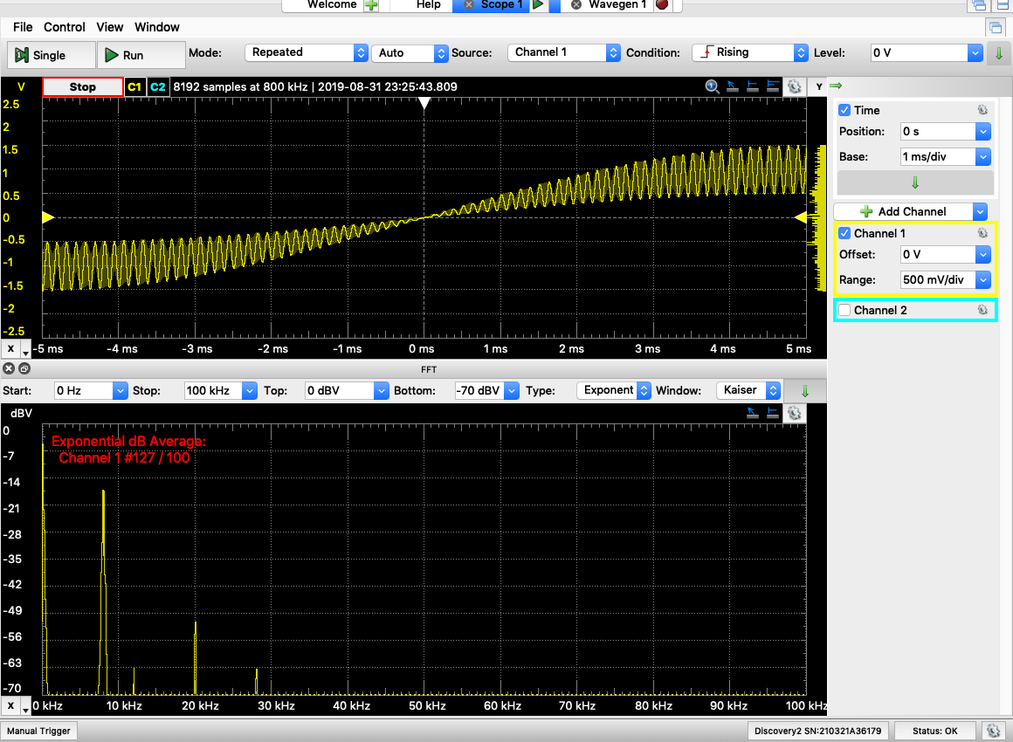
What should a filter do so that I am left with only my 8 kHz signal?

We will now build two filtering circuits and test how they each respond to input voltages.
.
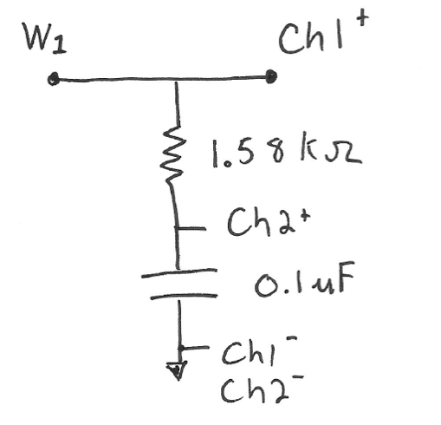
1. Build the RC circuit shown; it will filter V_{in} (=W1).

(R)
(C)

Quit Waveforms and reopen to get the default settings.

2. Connect the Discovery to your circuit.
Ensure the Discovery and circuit share a ground.
Use Wavegen 1 as the V_input signal.
Use Scope Channel 1 to monitor the input signal;
Use Scope Channel 2 to monitor the V dropped across the capacitor; we will consider this the filter output.
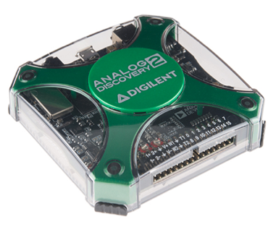

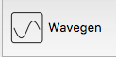
3. Set , then ►Run

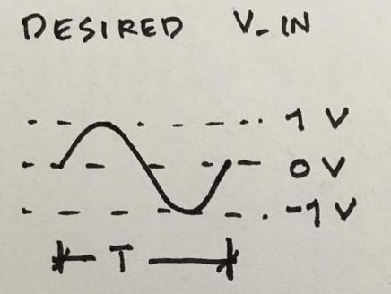
Your circuit has a natural response when 1=ωRC, or RC= 𝜏 (“tau”)= $\frac{1}{2πf}$ .

Choose a signal input $f≅\frac{1}{2πτ}$; 2 significant figures are sufficient.

When you’ve set up the signal, ►Run

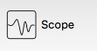
4. Add and set up , then ►Run

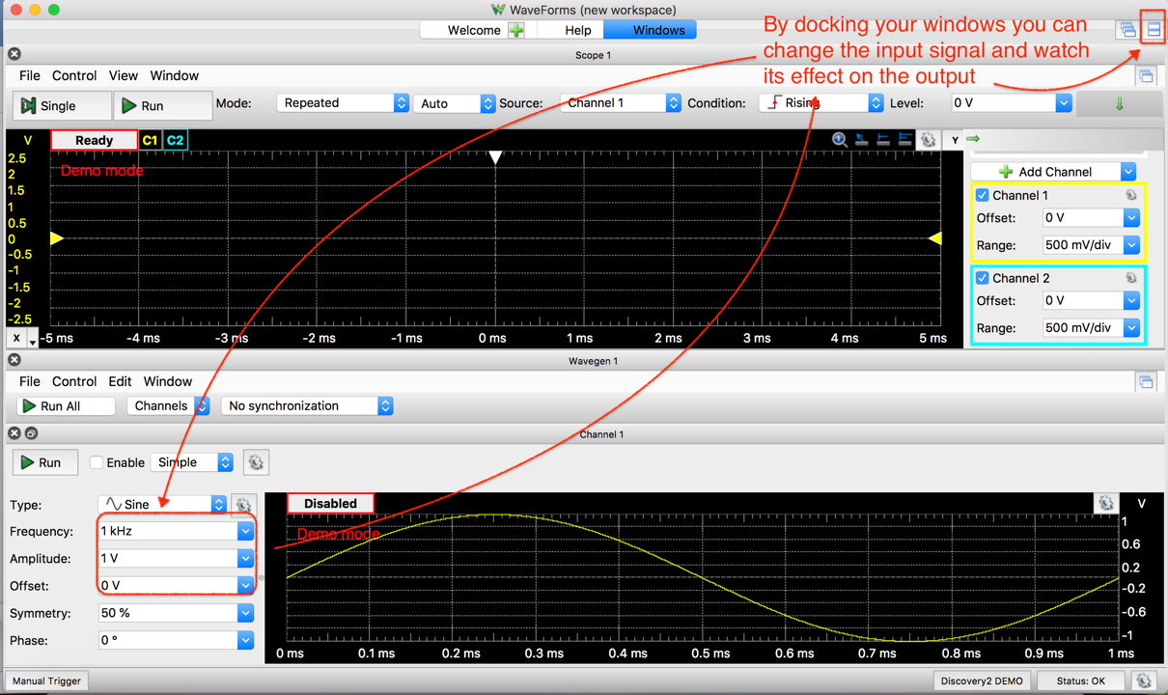
Adjust the frequency of the sine wave to be ~10x lower- and ~10x higher- than $f≅\frac{1}{2πRC}$, which is the RC filter’s characteristic frequency.
5. Pilot test the circuit: Change the input frequency and notice the response
Observe how the filter behaves qualitatively below its characteristic f (“low” f) and above f (“high” f).

Notice the amplitude of the output as well as the shift in time, Δt, between V_{in} (Ch1⁺) and the V_{out}(Ch2⁺).

If your circuit is working as expected, it will allow some frequencies to pass through to V_{out} and it will block others. Check with someone else who has a functioning filter. Are your filters responding similarly?

Record your observations on the worksheet (pp. 11-13).

6. Measure and quantify how this RC circuit responds to different frequency inputs
We will model the input to the RC circuit as a sine wave: $V_{in}=sinsin \left(ωt\right)$, where ω is the angular frequency in radians/second (also “rads/sec”). The sine function takes an argument in units of radians.

How do you convert cycles/second (Hz) to radians/second (ω) for the sine function?

[Hint: This animation illustrates Hz ➠ω: How many 𝝿 radians are in a complete, 360° cycle?]
The output is expected to be $V_{out}=A∙ V_{in}\left(ωt+ϕ\right).$ From the book, we know that output amplitude, A, will be:
$A= \frac{V_{out}}{V_{in}}= \frac{1}{\sqrt{1+{\left(RCω\right)}^{2}}}$= voltage gain

And the angular shift in phase is:
$ϕ=(-RCω)$

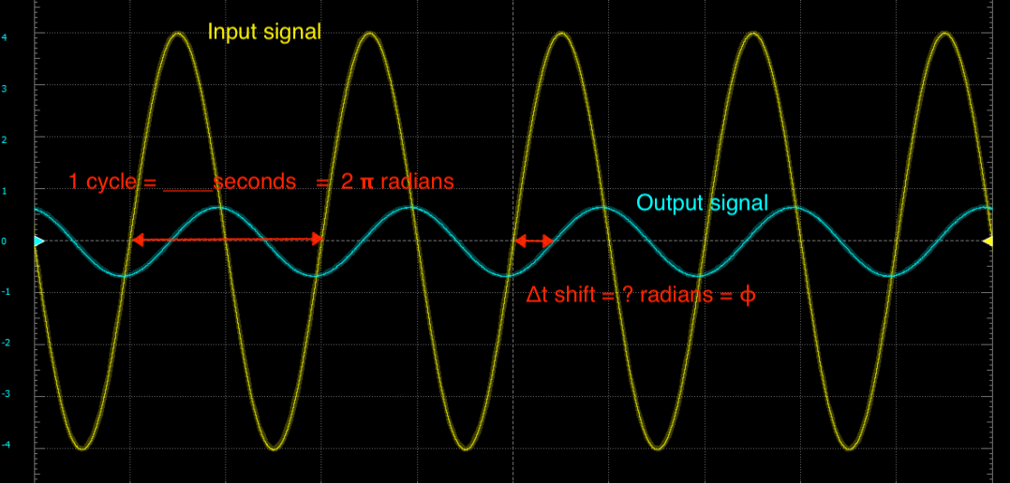
In Waveforms, the data displays in the time domain (seconds).
You can compute 𝜙 by measuring the time shift, Δt:

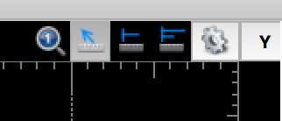

Use this tool to measure Δt.
Compute the phase shift at the characteristic frequency of this RC filter, 1 kHz.
Record your observations on the worksheet (last page).
The moment you’ve been waiting for…the Bode plot will assess the performance of your filter in just a few seconds. There is no need to change your circuit or Analog Discovery set up from the last step—it will use the same channels.
7. Analyze the circuit behavior with a Bode plot

Close the windows in Waveforms.
Add a component. This component is Wavegen and Scope wrapped into one. It displays the frequency response of the circuit in what is called a Bode plot*

*Bode plot: Each Bode (pronounce boe – dee) plot is really 2 plots – a plot of Gain (A) v. frequency, and a plot of phase angle (𝜙) v. frequency.
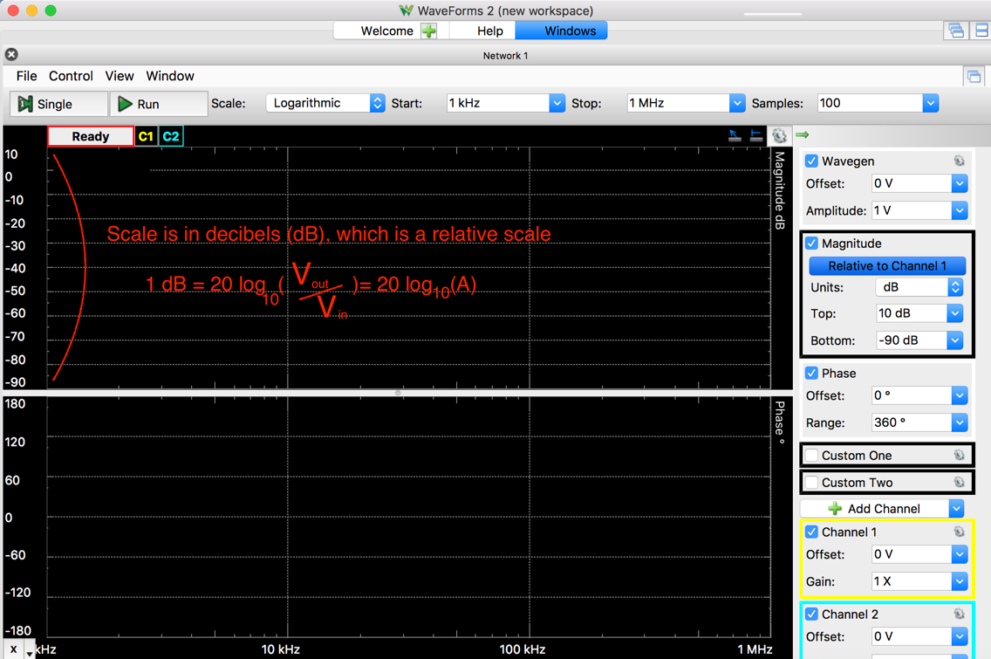
Adjust the frequency range, Start: 10 Hz; Stop: 100 kHz.
You may want to adjust this range later.

Use to produce a single sweep.
Save the Bode plot data with File>Export.

The Bode plot on the scope will default to display in decibels (dB). The dB is a relative measure of Power gain, 1 dB = 10 log (A_{power}). Because P = IV = V²/R = I²R, ${Gain}_{Power}={Gain}_{Voltage}^{2}= {Gain}_{Current}^{2}$, For your experiment, A = $\frac{V_{out}}{V_{in}}= \frac{1}{\sqrt{1+{\left(RCω\right)}^{2}}}$= voltage gain.
Export the image of the Bode Plot results from the Network Analyzer for later reference.
Record your observations in the worksheet.

Remember the experimental output will be in dB while the amplitude, A, is just the ratio of output voltage to input voltage. See the book for converting to (or from) dB.
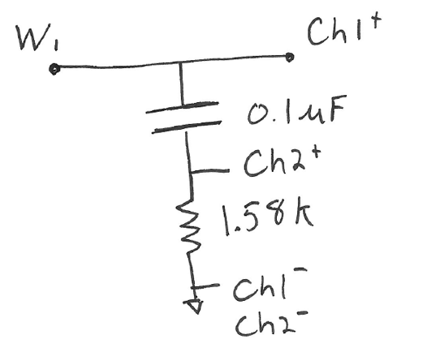
8. Build and test a CR circuit by hand (step 6.) and with a Network Analyzer (step 7)
The V_{out} in this CR circuit measures the voltage dropped over the 1.58kΩ resistor. How is this different from what V_{out} measures in the RC circuit?

(C)
(R)

Leave the Analog Discovery hooked up.

Quit Waveforms and re-start to return to the defaults.

Let’s create an input signal that has known frequencies above and below the RC filter. Follow the steps described in Part I, Steps 1 and 3, above, with these modifications:
Record your observations on the worksheet.

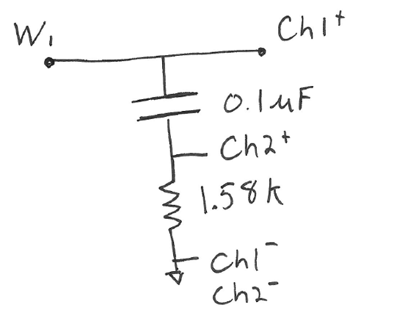
9. Build and test a CR circuit by hand (step 6.) and with a Network Analyzer (step 7)
The V_{out} in this CR circuit measures the voltage dropped over the 1.58kΩ resistor. How is this different from what V_{out} measures in the RC circuit?

The expected results for amplitude and phase are;
$A= \frac{RCω}{\sqrt{1+{\left(RCω\right)}^{2}}}$

$ϕ=atan⁡\left(\frac{1}{RCω}\right)$
10. Generate a Bode plot for the CR circuit
Recreate a Bode plot using the Network Analyzer as you did in step 7 with the RC circuit.
Export the image of the Bode Plot results from the Network Analyzer for later reference.
Record your observations in the worksheet.

Problem set: RC circuits as signal filters—FFTs and the Bode plot
Worksheet

Part I: Viewing signals through time and 1/time domains

The FFT uses a relative amplitude of the voltages using the decibel (dBV),
$dBV=20 ∙\log_{10}\left(\frac{V}{V_{ref}}\right)$
For our case, the 1V (“Carrier” signal amplitude) is the V_{ref}.
How pure is Wavegen’s 1kHz signal?
What do you notice about the frequency composition of Wavegen’s 1kHz signal?

What are the amplitude (volts) and frequency (kHz) of the largest signal that is not 1 kHz? (Use 2 significant figures).

The dimensions of frequency are hertz, 1 Hz = 1 cycle/second. What is the “cycle” that the Hz is referring to?

Effects of adding two signals
First remove both “FM” and “AM” and restart the Scope.
Now add in “FM” 20kHz signal. What happens to the FFT?

What accounts for signals that appeared in the FFT that are not 20kHz?

Now add in “AM” (50kHz). What do you observe in the FFT output?

Now that you’ve had a little experience with FFTs, how do you imagine that they can help you build a filter?

Part 2. The RC filter and its behavior: The Bode plot
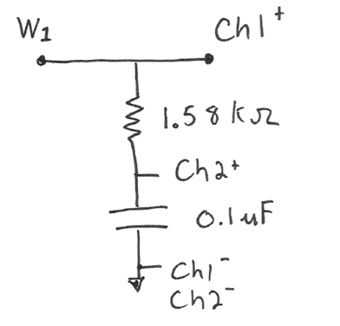
For the RC circuit, describe what you see happening to the signal amplitude when the input goes from low frequency (~100Hz) to high frequency (100 kHz).

Compute the phase shift at the characteristic frequency. This phase shift should be the same for all filters at the characteristic frequency.

What does the Bode plot tell you about the RC filter’s response to low($f<\frac{1}{2πτ}$ )and high($f>\frac{1}{2πτ}$ ) frequencies? (Is this the same as what you’ve observed?)

For step 8, View the FFT and use the tools to determine:

- $\frac{V_{out}}{V_{in}}$ at the characteristic frequency (in dB_{v})
- $\frac{V_{out}}{V_{in}}$ at 10 x characteristic frequency (in dB_{v})
- Change in V_{out} per 10x change in f , above the characteristic frequency.
This signal attenuation/decade is an important performance metric for filters.
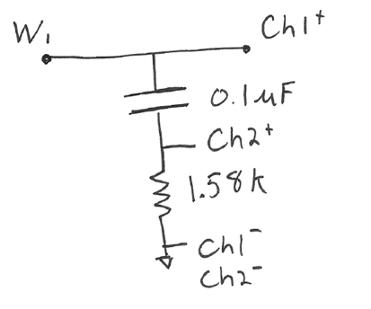
What does the Bode plot tell you about the performance of the CR circuit at low and high frequencies?

Like the RC filter, this CR filter is a 1st-order roll-off filter.
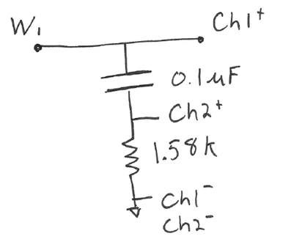
Let’s name these circuits! Match the names below with a good name for each circuit:
High pass filter (allows “high” frequencies to pass through)
Low pass filter (allows “low” frequencies to pass through)
band pass filter (allows a limited band of frequencies to pass through)
Naming options:

